Nlp tutorial:

[NLP Tutorial 6 - Phone Number, Email, Emoji Extraction in Spacy for NLP | NLP with SpaCy - YouTube](https://www.youtube.com/watch?v=9FQTG0Pzv6E)

[End-to-End Complete Spacy 3 Masterclass Tutorial - YouTube](https://www.youtube.com/watch?v=M6wiGQ-cbdE)

[SpaCy Python Tutorial - Introduction,Word Tokens and Sentence Tokens(Natural Language Processing) - YouTube](https://www.youtube.com/watch?v=Y90BJzUcqlI&list=PLJ39kWiJXSiz1LK8d_fyxb7FTn4mBYOsD&index=2)

[Natural Language Processing with spaCy & Python - Course for Beginners - YouTube](https://www.youtube.com/watch?v=dIUTsFT2MeQ)

Named entity : [Training Spacy's Named Entity Recognition to Recognize Drugs - NLP in Python - YouTube](https://www.youtube.com/watch?v=-NwubHjjzcw)

Spacy:

Toolin nlp

Spacy 3.0 is better

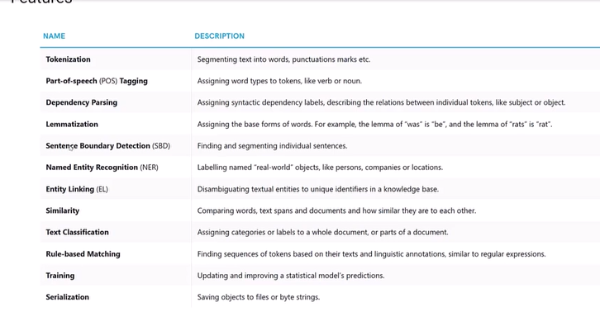

Sentence Boundary Detection: filtering and segmenting sentences

NER- real world objects like person name, location, company

Entity linking:if we have knowledge base, how these entities are related to knowledge base

Similarities

Rule based matching-regex matching

In spacy we have 3 models

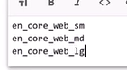

Small

Medium

Large

Spacy library

[Install spaCy · spaCy Usage Documentation](https://spacy.io/usage)

Linguistic annotations:

Combination of all features of spacy

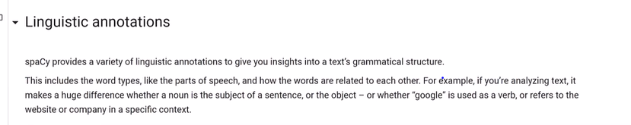



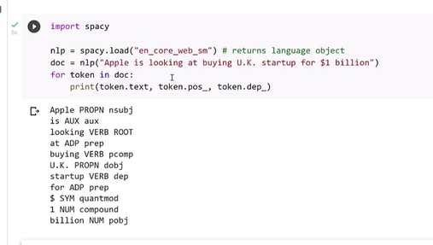

Even though a doc is processed e.g split into individual words and annotated, it still holds all information of the original text like white spaces characters

This way you will never loose any infor when processing text with spacy

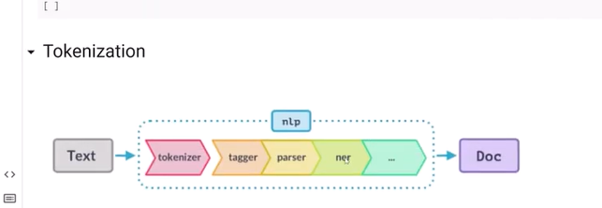

Parsing=dependency parsing

Doc object produces, in docs all information available

Tokenization:

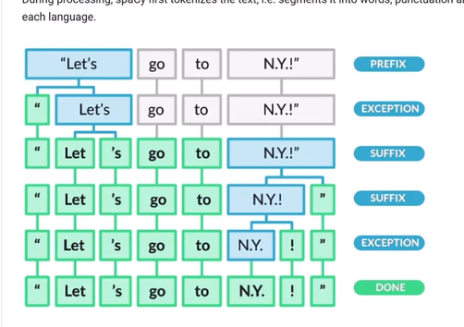

How tokenization happens

By default space

But spacy has special feature where it can break sentences based on prefix,suffix exception,infix

Exceptions=== language dependent

“ is prefix of let’s so it breakdown and made separated

N.Y.!” there “ is as suffix

Again exception happen and broke !

N.Y it wont break as it knows its city name

Import spacy

Nlp=spacy.load(“en_core_web_sm”)

Doc=nlp(text)

Doc

It print text

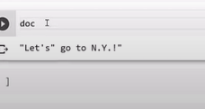

You need to do for

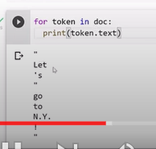

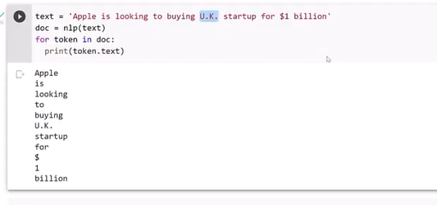

It knows uk as city

Pos:

After tokenization,

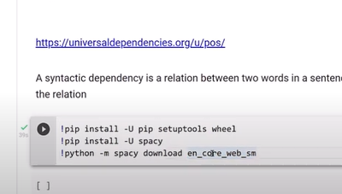

En­_core_web_sm :

Model which are used to get pos and dependency parser

Part of speech tagging and dependency parcing :

There is trained component includes binary data that is produced by showing a system enough examples for

Pre-trained model “en_core_web_sm”

---doc object can access

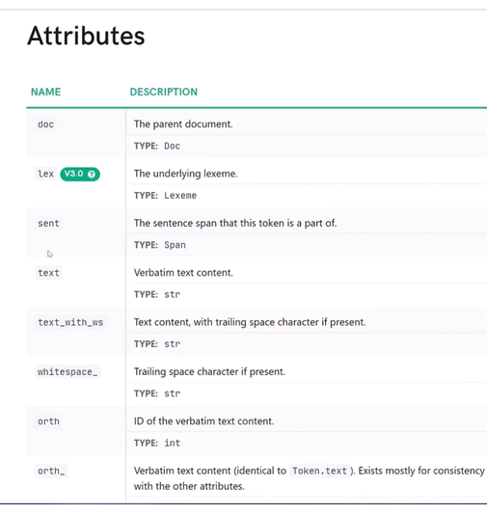

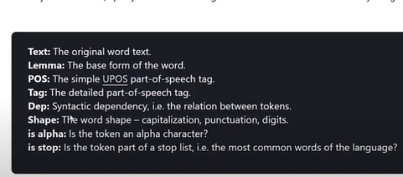

All these values are saved in hash values

Inorder to access them we need to mention_

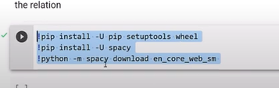

Import them

After that

Import spacy

Nlp=spacy.load(“en_core_web+sm”)

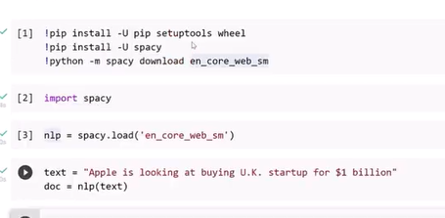

The aatributes we can access doc object

In order to access them we need to use loop

In order to make them beautiful we need to install beautifultable

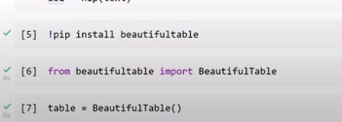

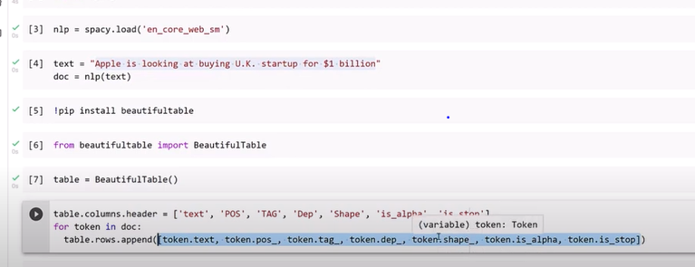

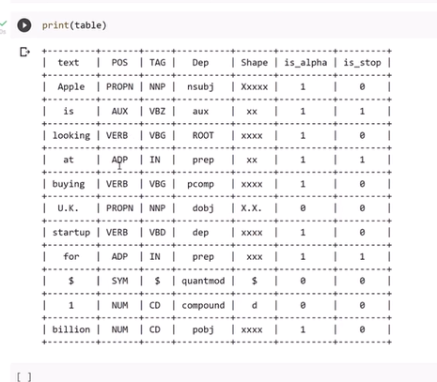

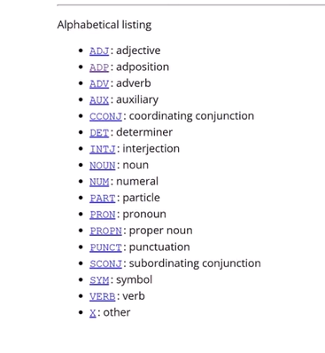

Tag tell what are dependent ,

Detailed pos explanation

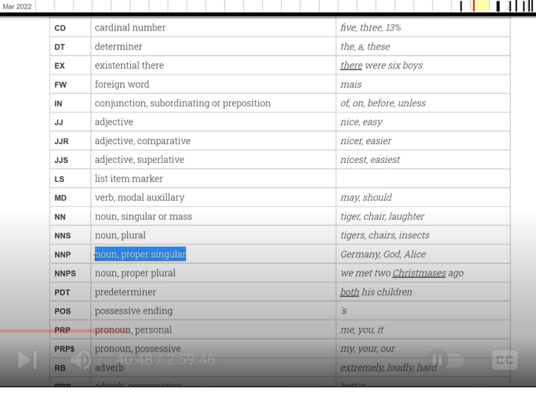

Dep: how these words are related to each other,

Syntactic dependency

One is governing one

Ptherone dependent

Looking-route word

Apple is non

Looking explains about apple

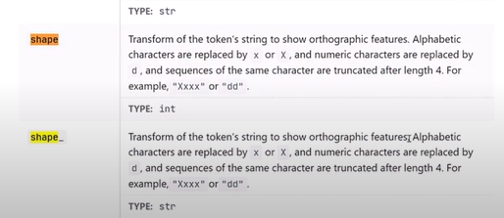

Alphabated replaced with X-capital,x-lower, d-numbers

Isalpha- complete alphabates ?

Is it stopwords”

Spacy.explain(token.tag_)

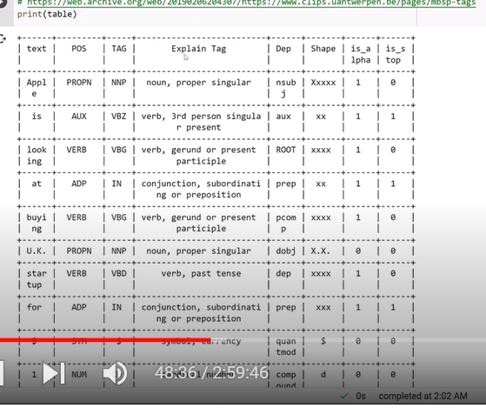

Dependency parsing:

Dep

Extracting dependent word from sentences

Root word – is head word not depended on any word

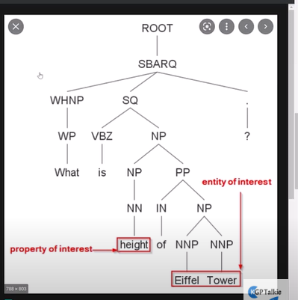

Displacy – must be downloaded to to display dependencies

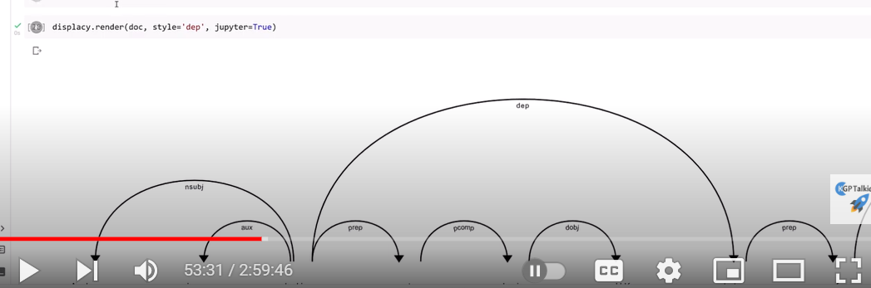

More better format

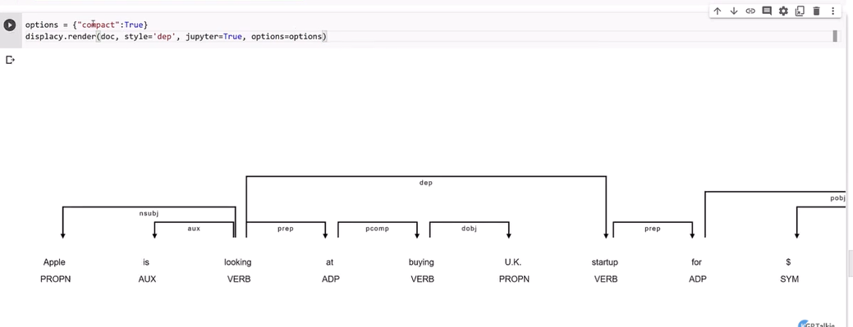

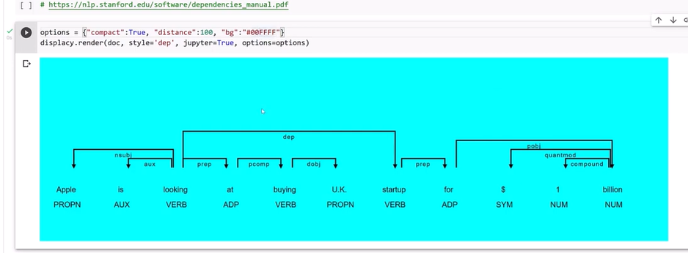

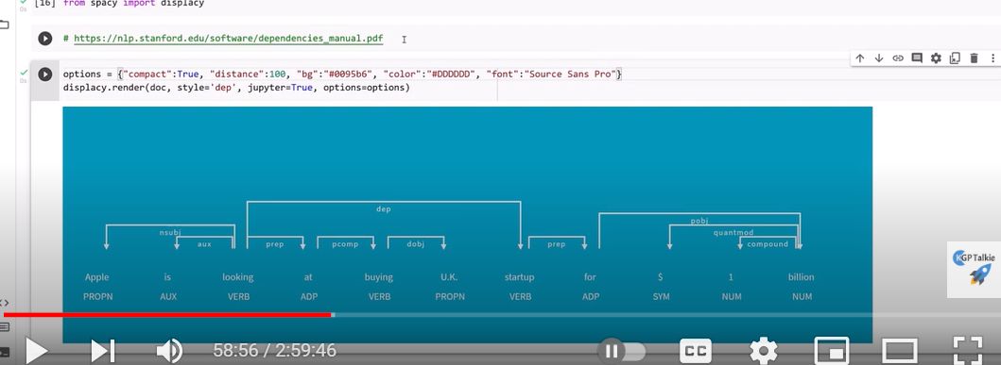

Sentence boundary detection:

Start and end of the sentences

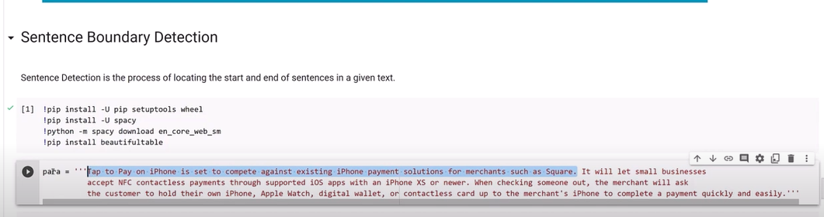

Import spacy

Nlp=spacy.load(“en_core_web_en”)

Doc=nlp(text)

If u type doc

You get original sentence

To get list

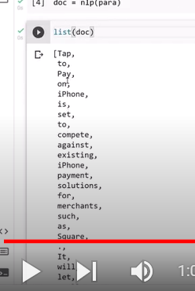

Sentences

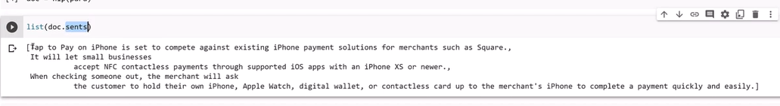

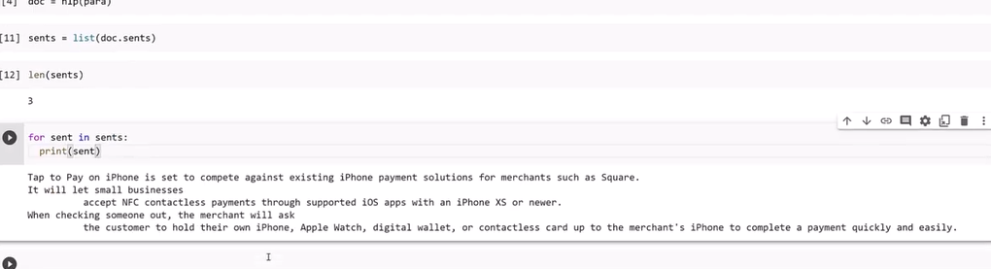

Stopword?

Common words in English language

Sometimes having these words will help us

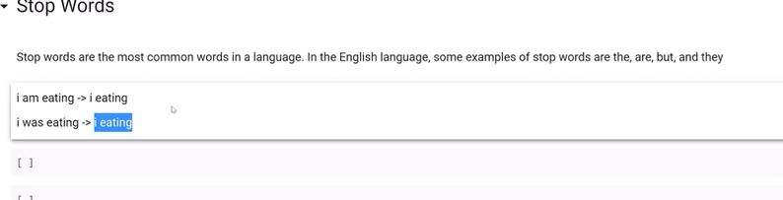

Stop words doent have any meaning as individual words

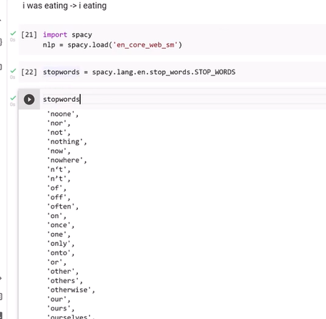

Sometimes these word are imp

Based on context of sentence

How to filter stop words?

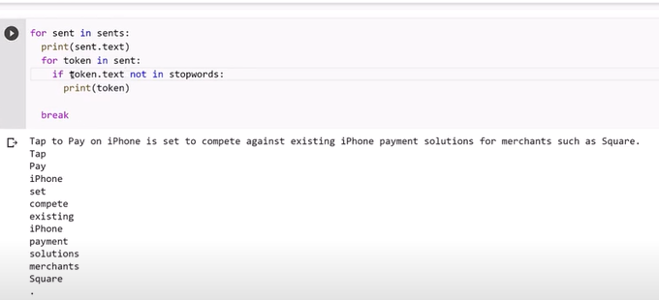

By mixing these word doent make any sense

We don’t get context of sentence

So sometimes removing them will help us, sometimes keeping them will help us

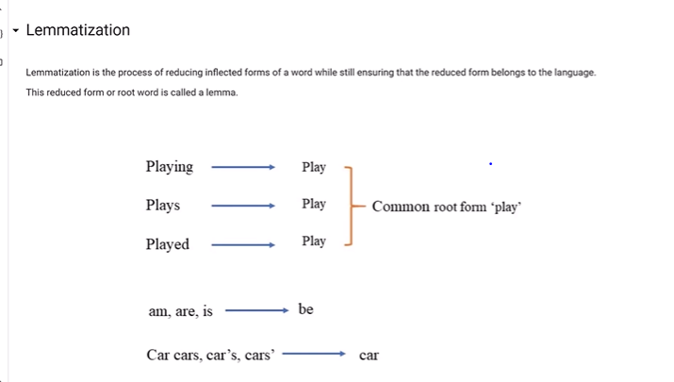

To reduce dictionary size

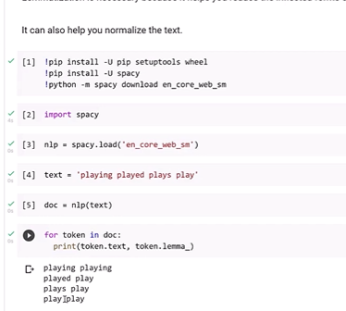

Spacy has no stemming

Nltk

Word frequency count:we can use various ways

We can find fre of data

Most occurring words and least occurring words

From collections import count

Word_freq=counter(text.split()

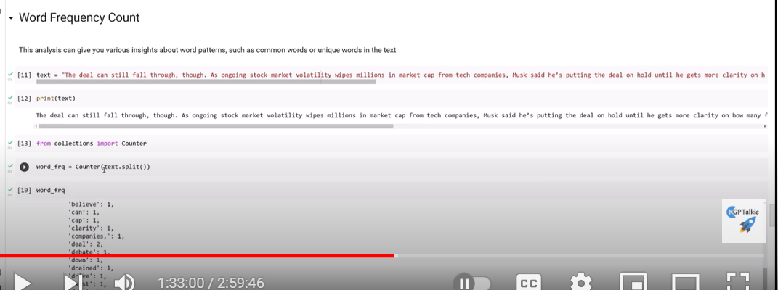

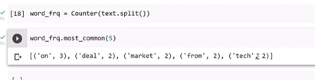

Most common

We can remove stop words and then calculate frequency of words

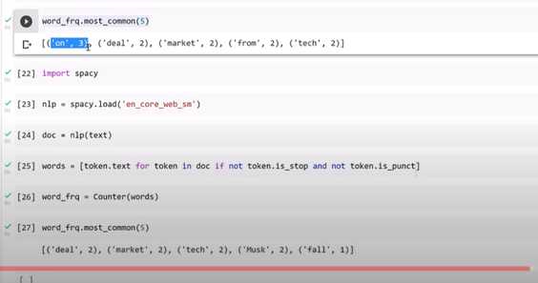

------------------------------------------------------------------------------------------------------------------------------------------------

Rule based matching in spacy:

We can define

token matcher

Phrase matches

Entity Ruler

---------------------------------------------------------------------------------------------------------------------------------

1. [The Basics of spaCy — Introduction to spaCy 3 (pythonhumanities.com)](http://spacy.pythonhumanities.com/01_01_install_and_containers.html)

Token match:

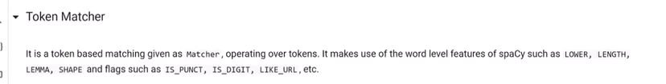

We can get

Lower

Length

Lemma

Shape

Is_punct

Is_digit

Like_url

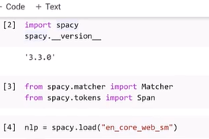

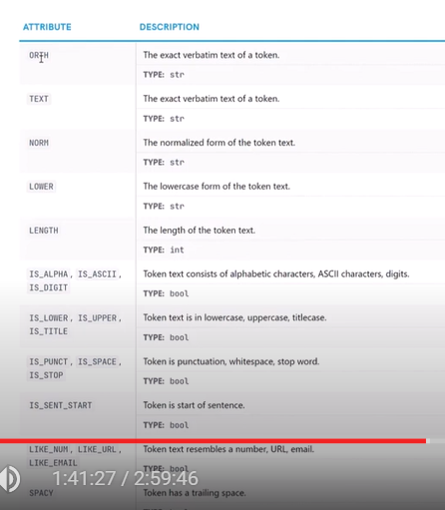

These are attributes of token

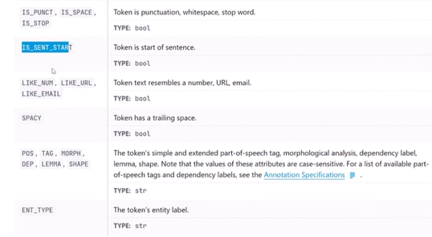

Here we need to find alice with verb ,not verb

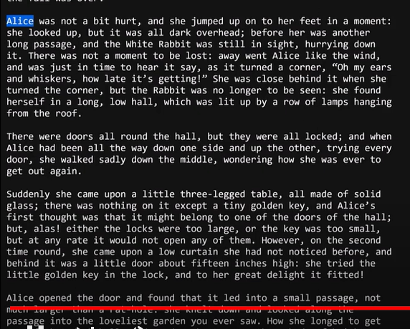

Here I need to mention in dictionary

Find

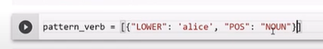

Make alice lower case

Find alice used as noun

Next token – find any part f speech where it is used as verb

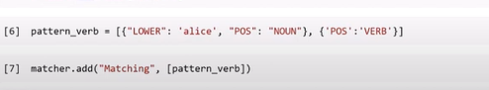

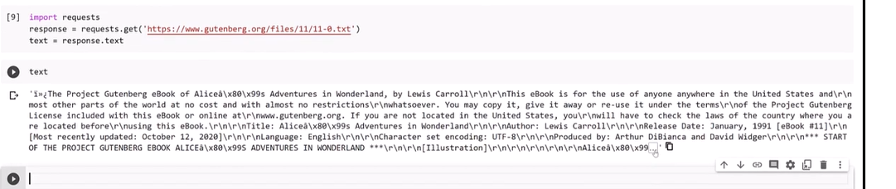

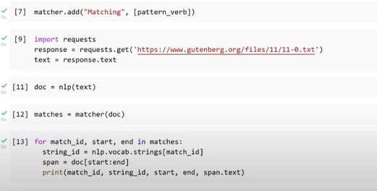

Now just see where alice used as noun

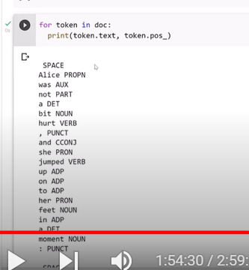

Here alice used as proper noun so we didn’t get

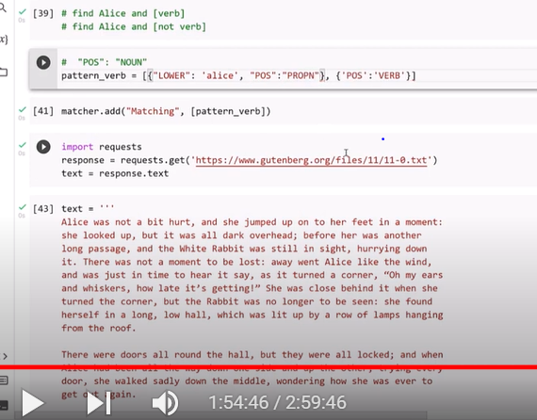

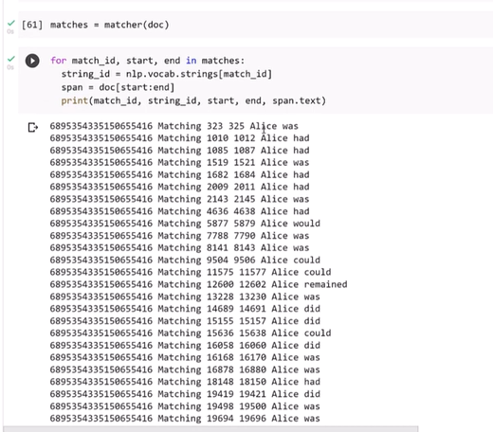

Alice where no aux word

After alice verb is not used

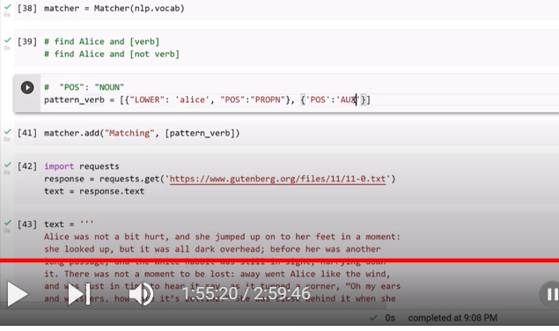

Pos match should we AUC

2 token matches were found

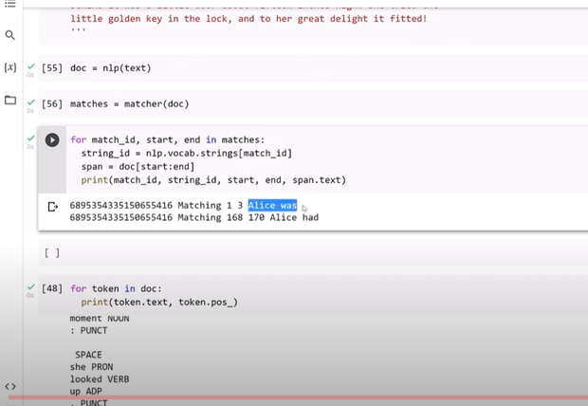

Match alice where no AUX word

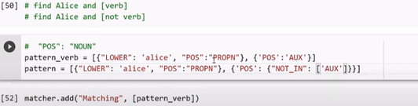

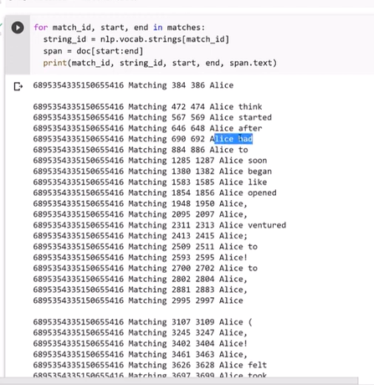

Rule base pattern matching

Adjuctive followed by nown

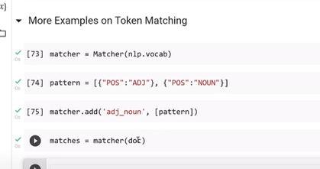

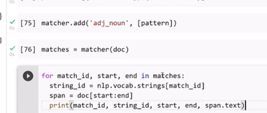

Matches object produces a tuple having match id,start,end

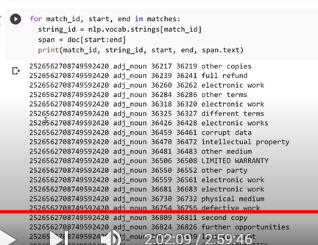

Now

Here we are matching any word which has lemma root word begin

After that followed by pos adj

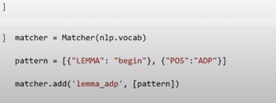

“lemma_adp” is name of pattern

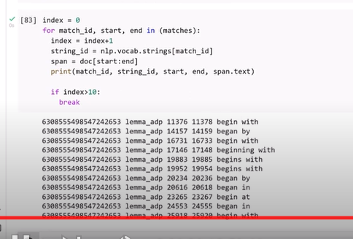

Rule based matching is very helpful

New match:

Text data : is exact text

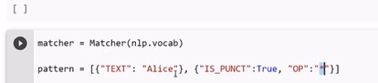

Original text Alica

After this punctuation

Op: optional

“* ”

Any other token is used after punctuation

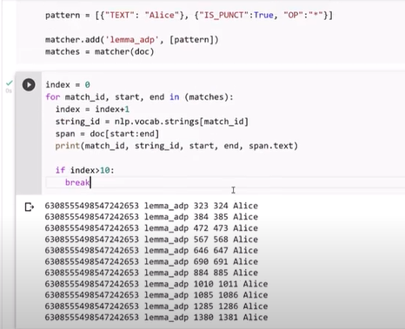

Phrase matches of spacy:

Phrase matches is much faster than token

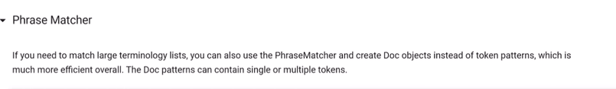

Nlp.vocab: all words

It match text data into lower case

Pharse list :

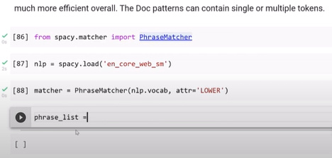

If we want to find complex tokens

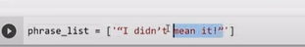

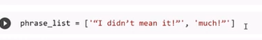

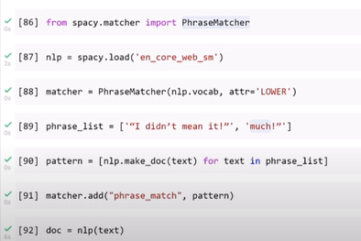

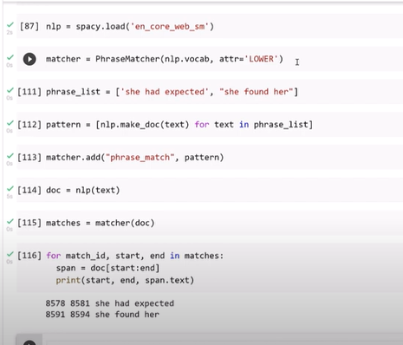

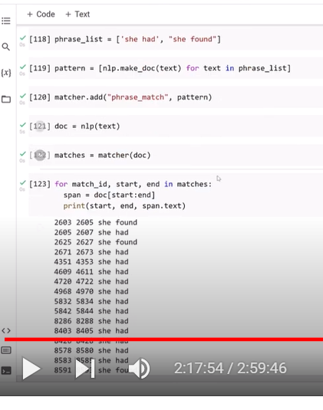

Entity matcher:

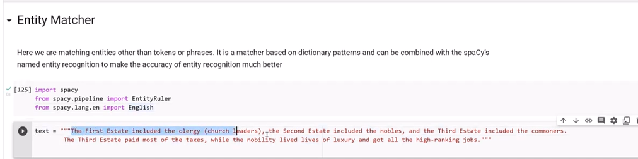

We need entityRuler

Language English

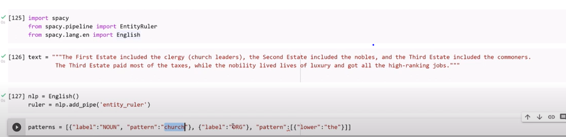

Here we are using church used as noun followed by lable organization



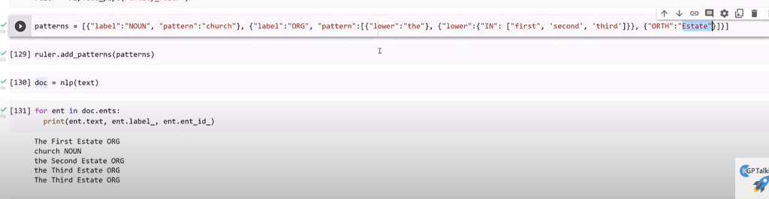

Named entity recognition:

When we want to find ner

Pretrained

Or

We can train our model

Entity proper:

Entity is real object with proper identification

Names: barak Obama

Org: face book

Time: tody

Product; appl

Geographic entity

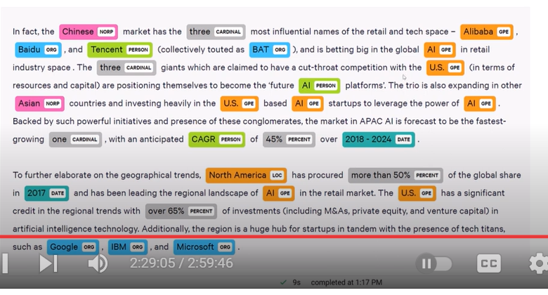

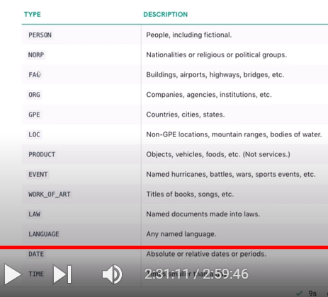

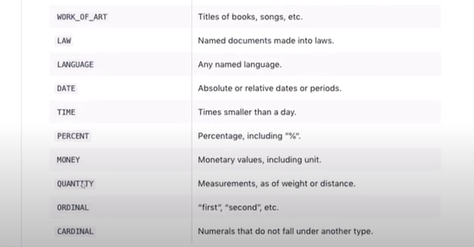

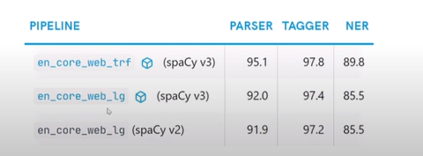

Imported large model

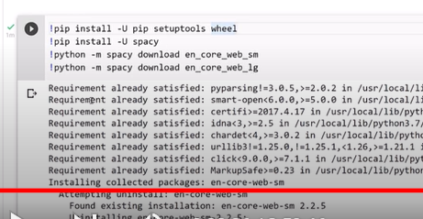

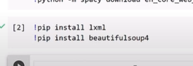

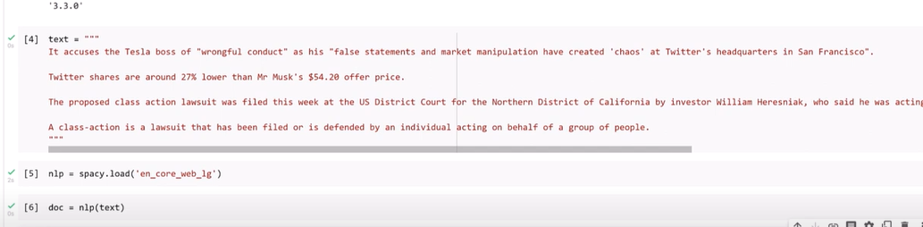

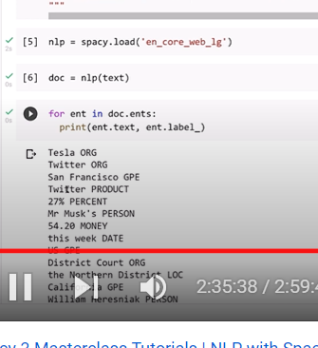

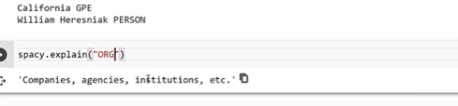

Ner classification:

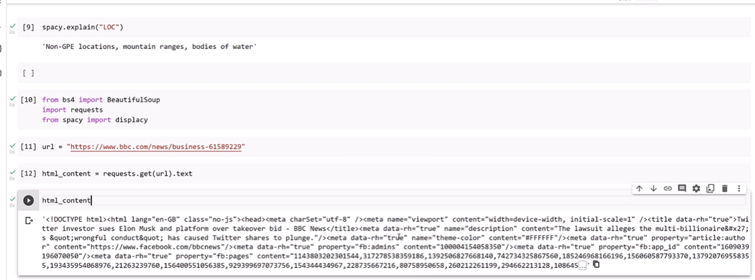

Lxml: parcer

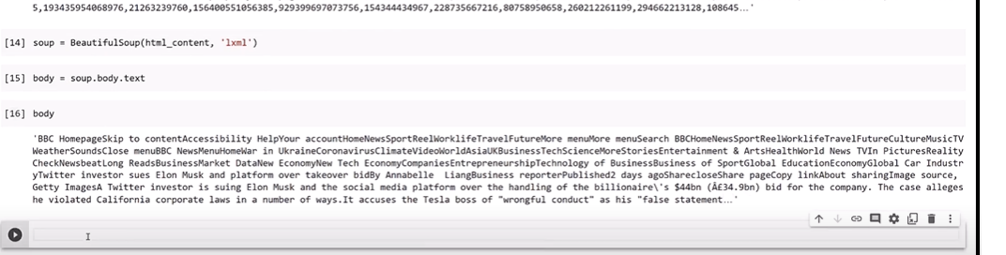

Which gets data in body

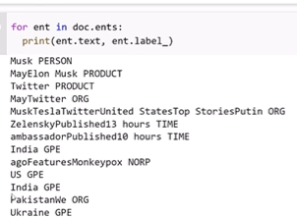

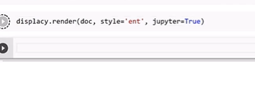

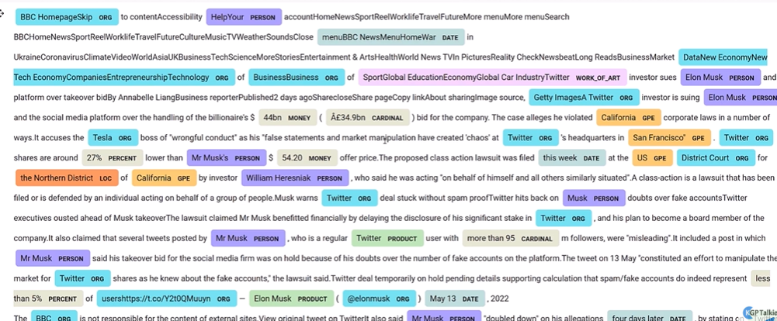

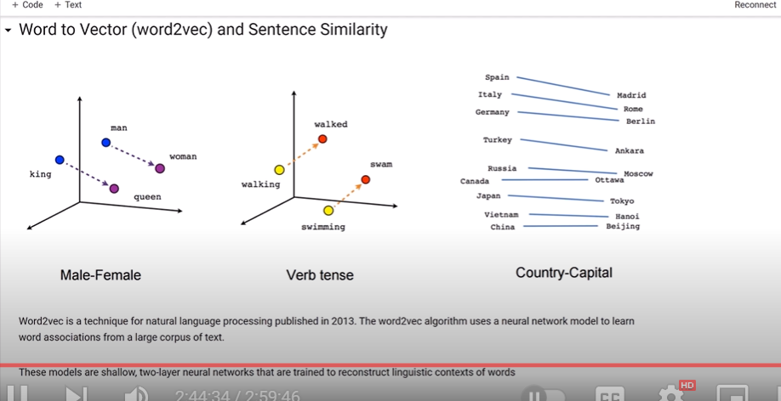

Machine learning cant understand text data

We need to convert to numbers

Bow,tfitd- converts into numbers

Where as word2vec: convert to : vectors

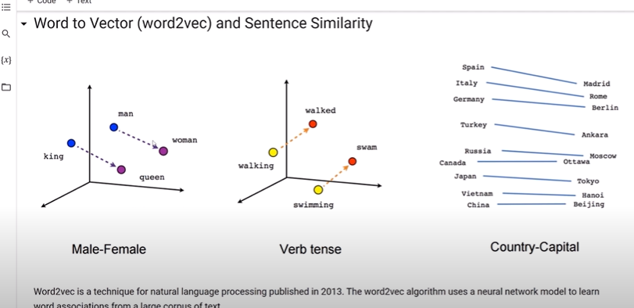

When dimention is large we have high space to project word accurately

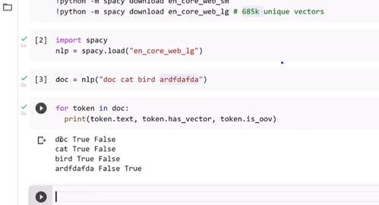

Vector, don’t have vector

Similarities between 2 doc,sentences

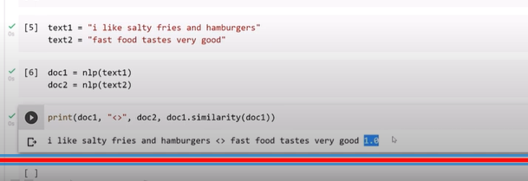

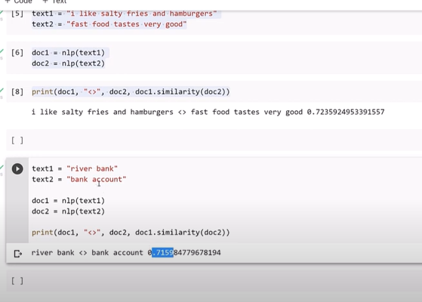

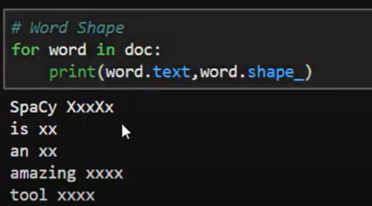

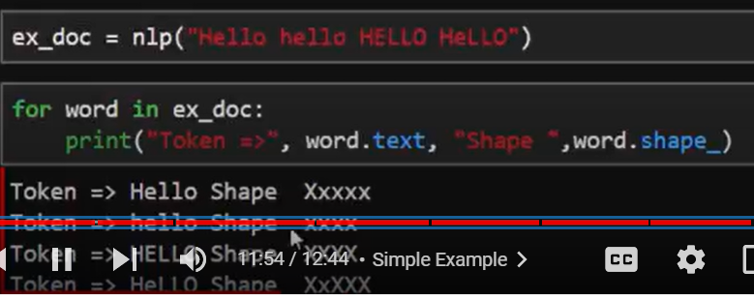

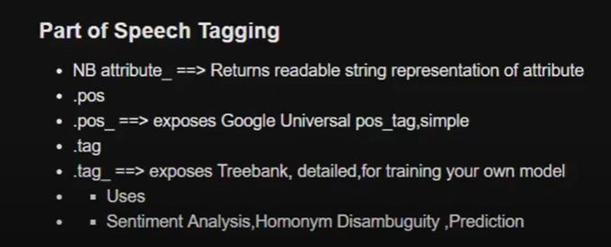

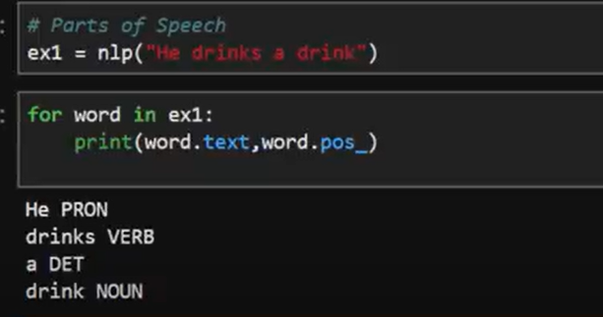

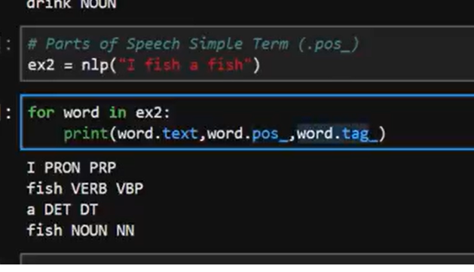

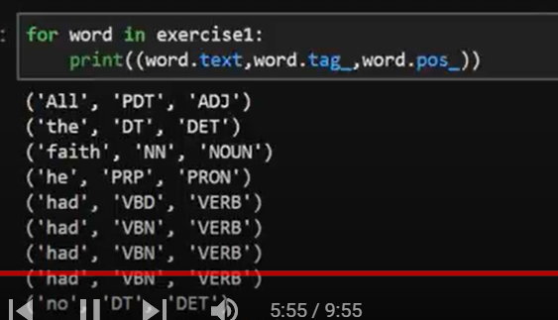

Syntactic dependencies

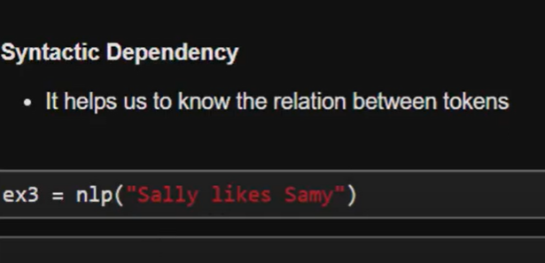

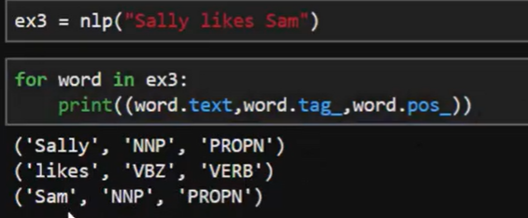

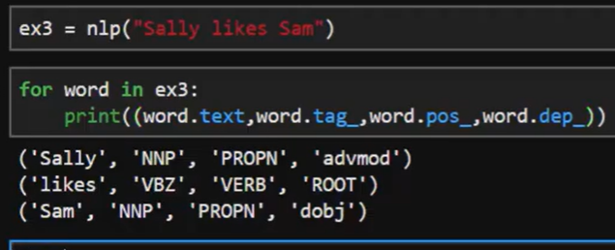

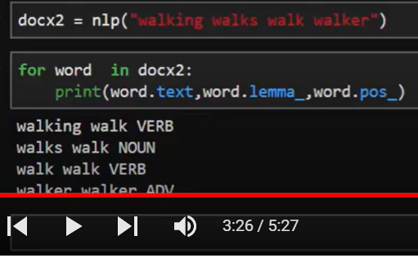

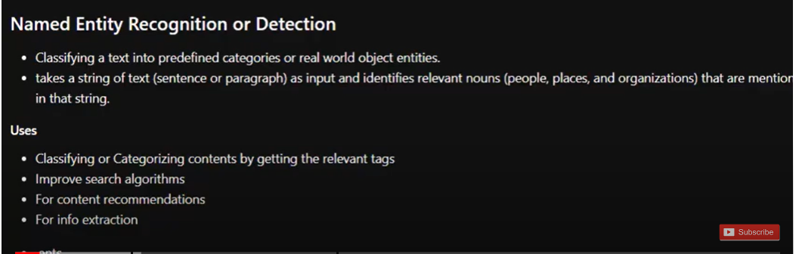

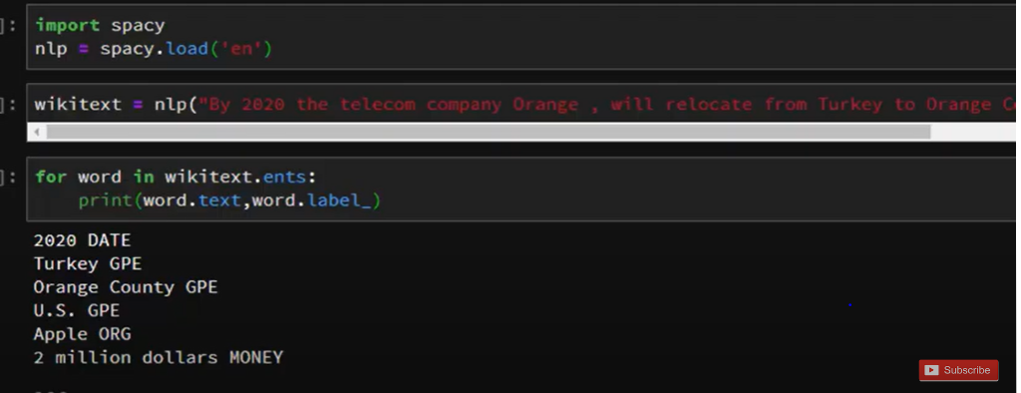

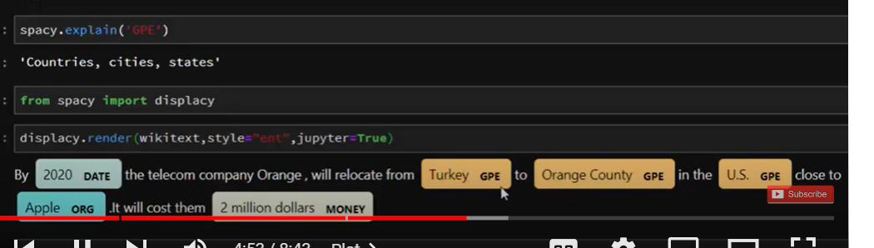

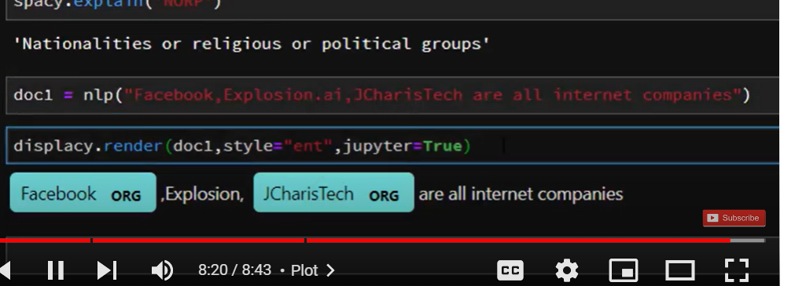

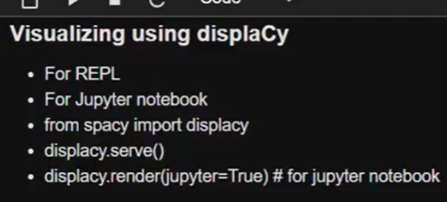

Displacy

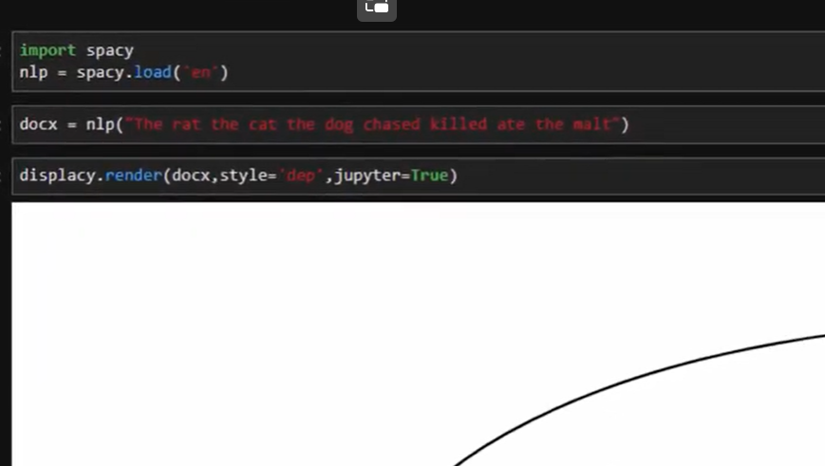

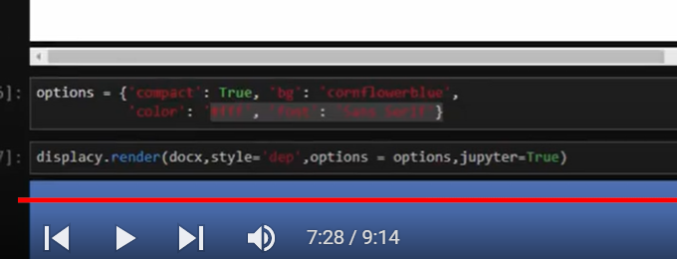

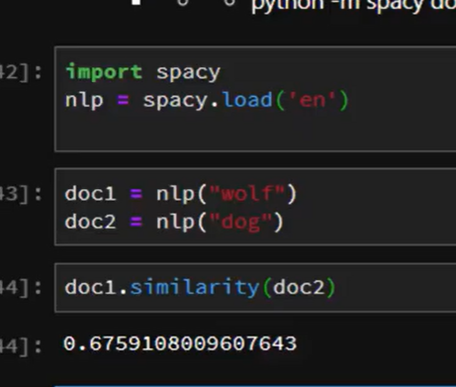

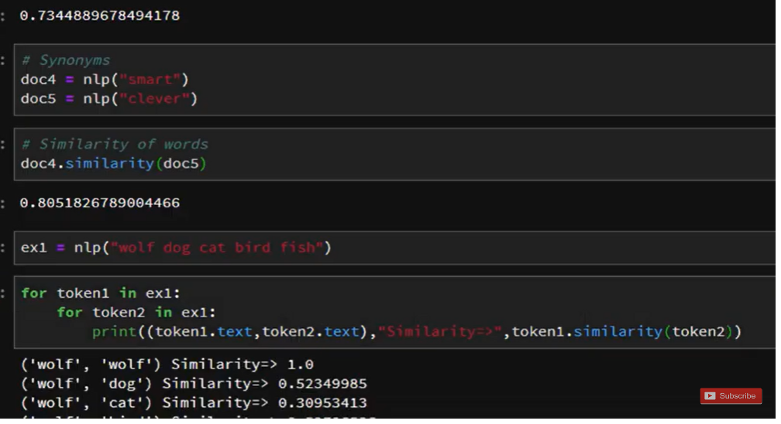

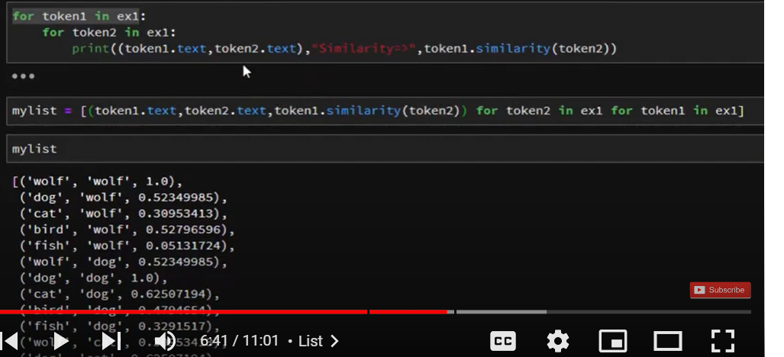

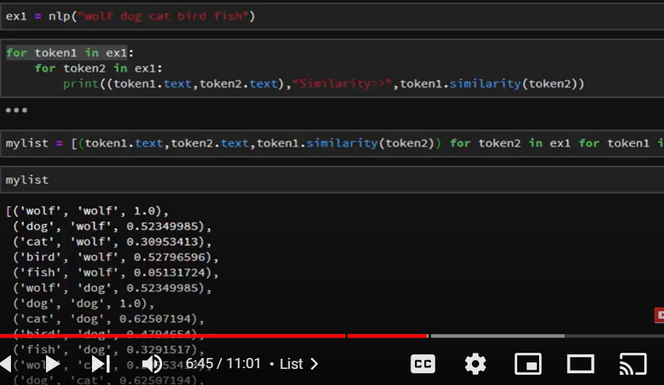

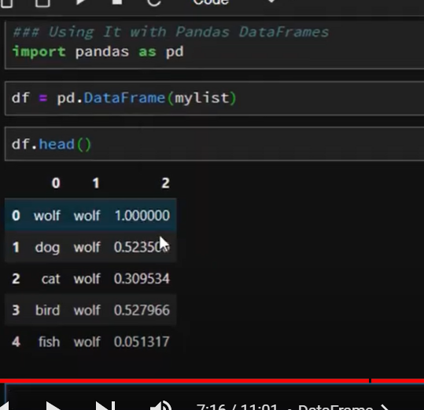

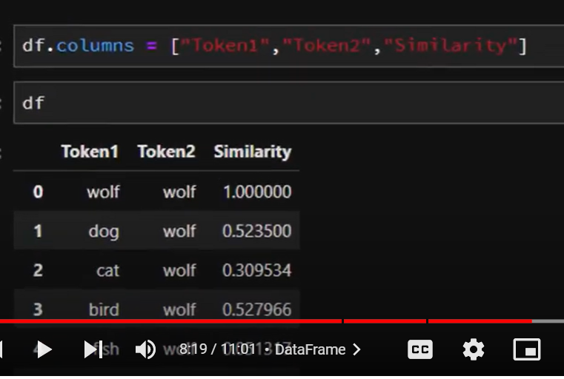

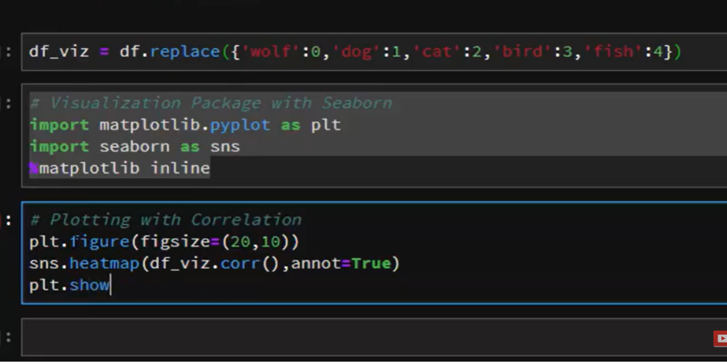

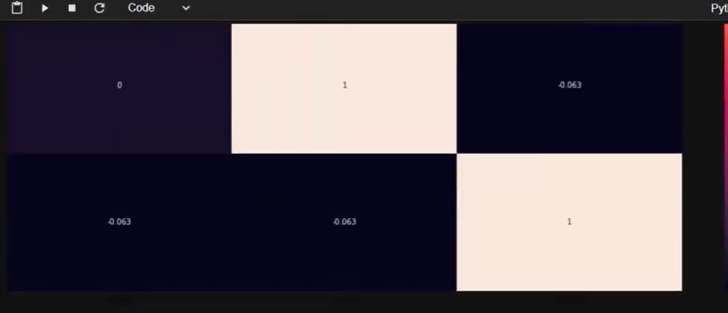

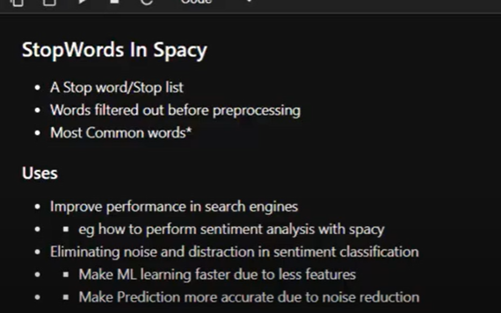

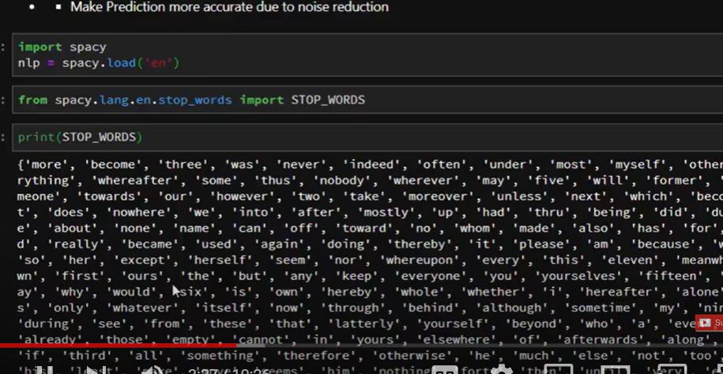

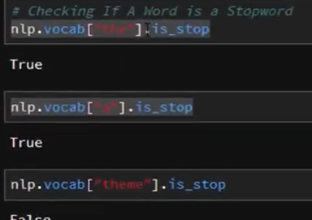

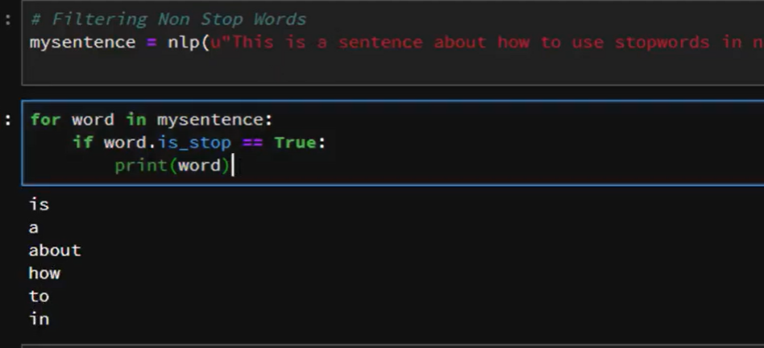

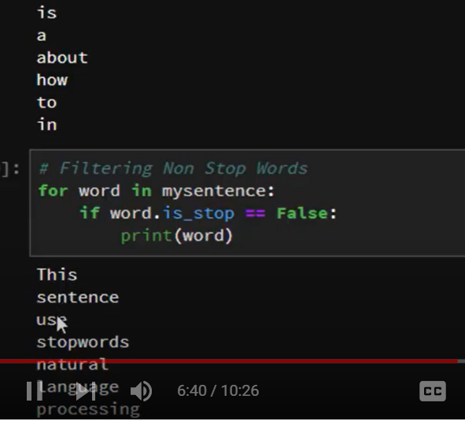

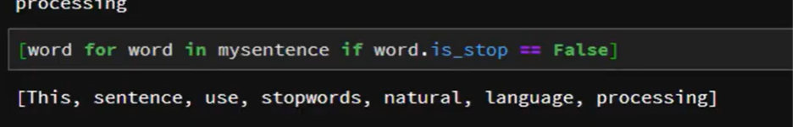

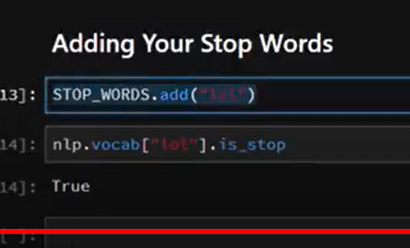

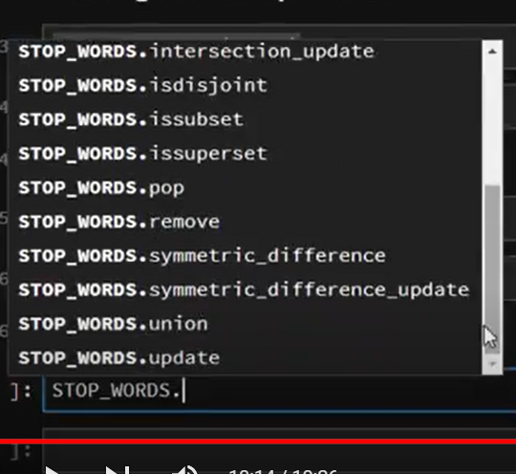

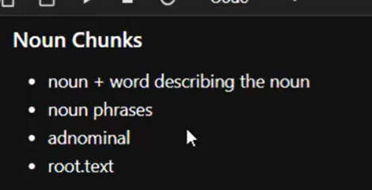

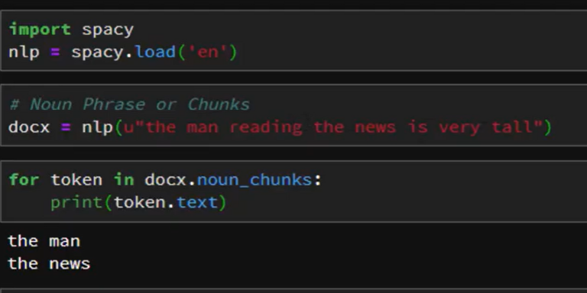

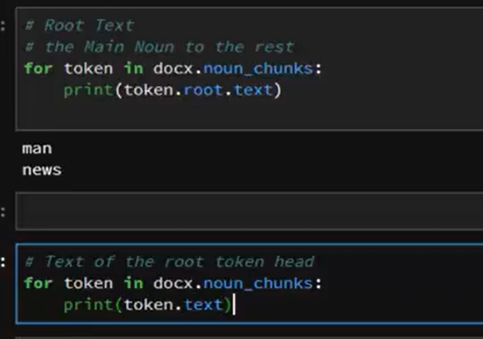

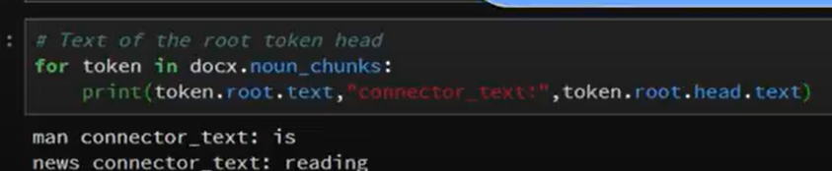

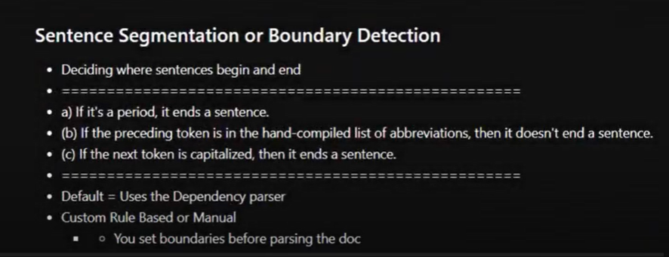

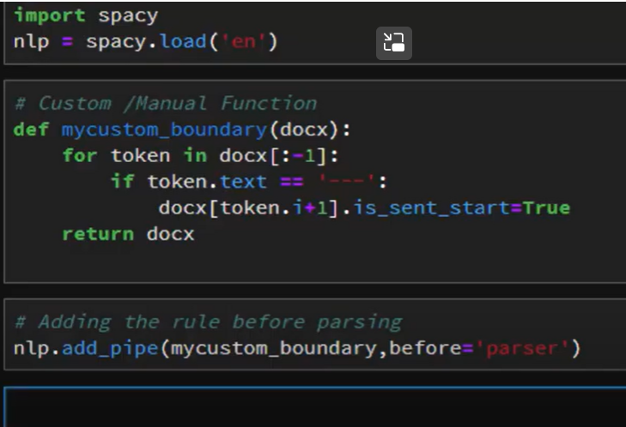

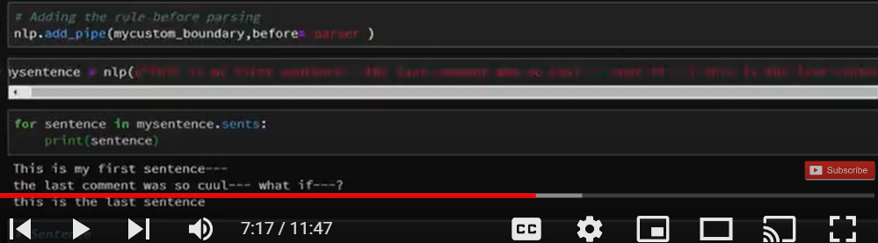

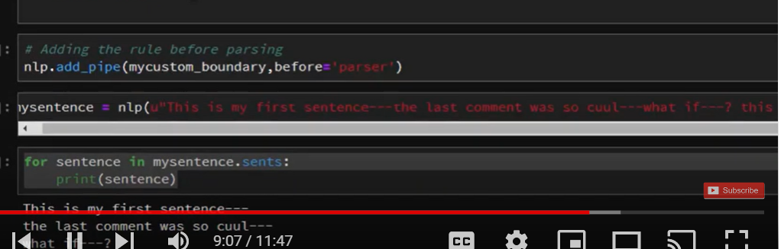

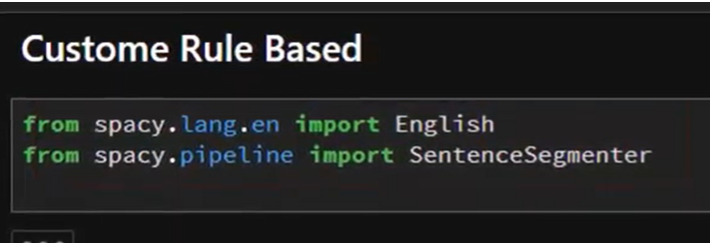

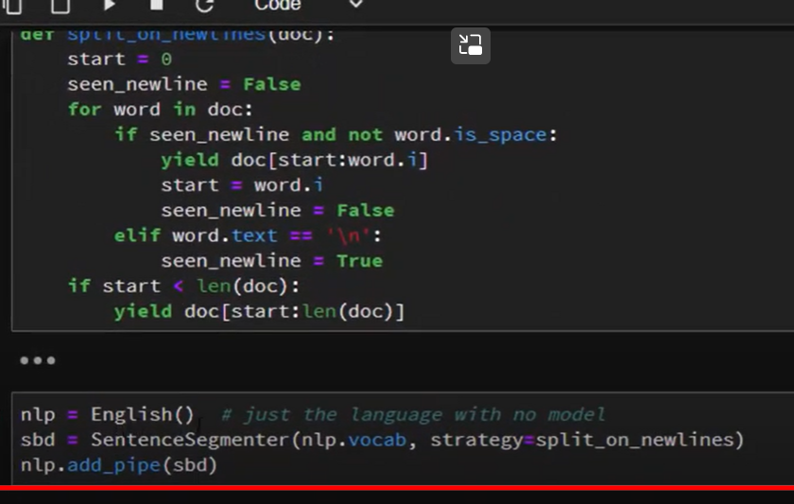

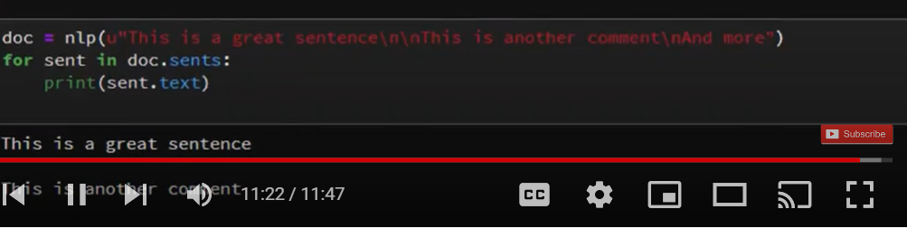

[Natural-Language-Processing-Tutorials/Intent Classification With Rasa NLU and SpaCy.ipynb at master · Jcharis/Natural-Language-Processing-Tutorials (github.com)](https://github.com/Jcharis/Natural-Language-Processing-Tutorials/blob/master/Intent%20Classification%20With%20Rasa%20-%20Spacy/Intent%20Classification%20With%20Rasa%20NLU%20and%20SpaCy.ipynb)

[Natural-Language-Processing-Tutorials/Text Classification & Sentiment Analysis with SpaCy,Sklearn.ipynb at master · Jcharis/Natural-Language-Processing-Tutorials (github.com)](https://github.com/Jcharis/Natural-Language-Processing-Tutorials/blob/master/Text%20Classification%20With%20Machine%20Learning,SpaCy,Sklearn(Sentiment%20Analysis)/Text%20Classification%20&%20Sentiment%20Analysis%20with%20SpaCy,Sklearn.ipynb)

Tra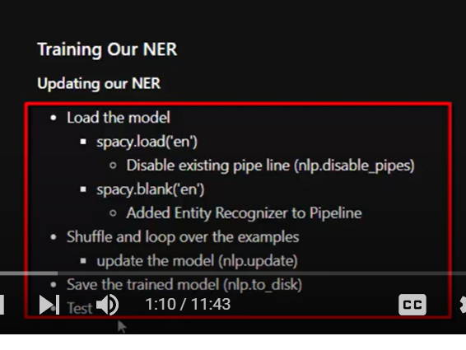

ining our NER

ner model- you should learn

[Natural-Language-Processing-Tutorials/Training the Named Entity Recognizer in SpaCy.ipynb at master · Jcharis/Natural-Language-Processing-Tutorials (github.com)](https://github.com/Jcharis/Natural-Language-Processing-Tutorials/blob/master/Training%20the%20Named%20Entity%20Recognizer%20in%20SpaCy.ipynb)

You must add

[2. Getting Started with spaCy and its Linguistic Annotations — Introduction to spaCy 3 (pythonhumanities.com)](http://spacy.pythonhumanities.com/01_02_linguistic_annotations.html)

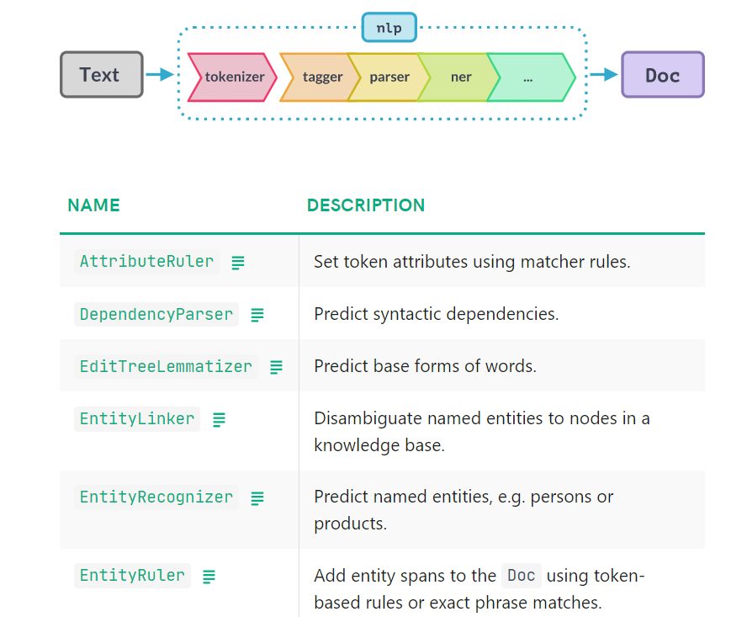

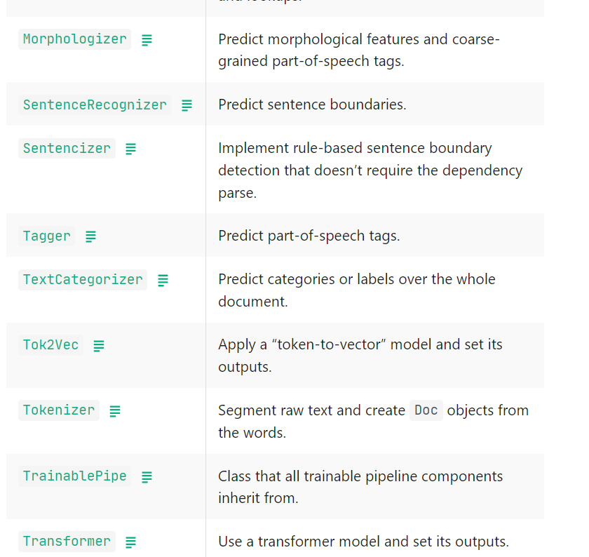

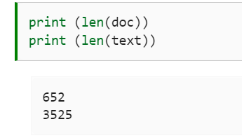

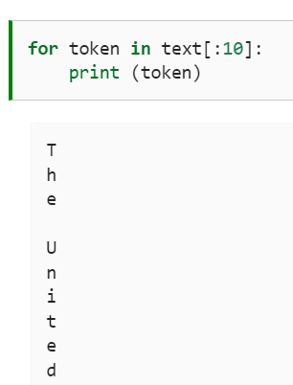

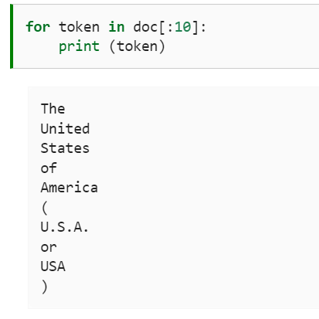

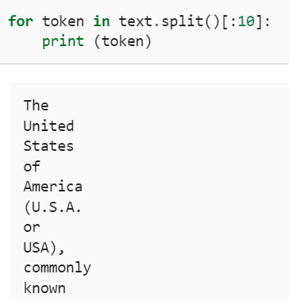

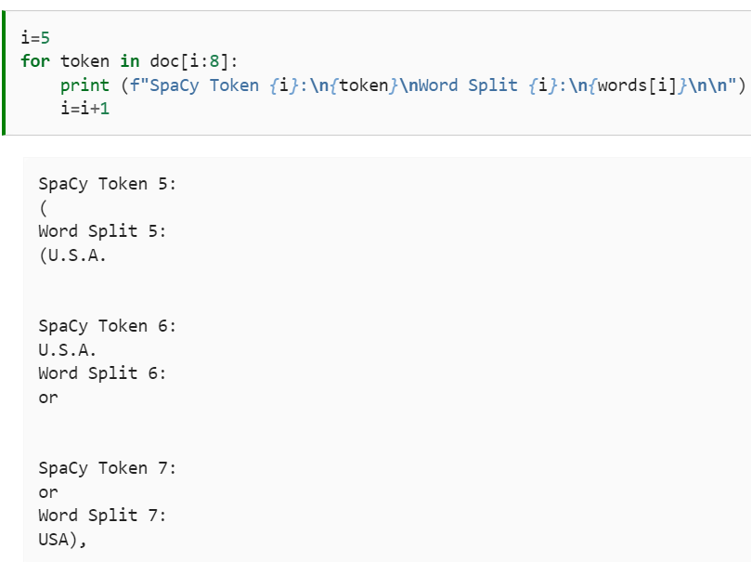

Sentence Boundary Detection (SBD)

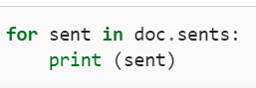

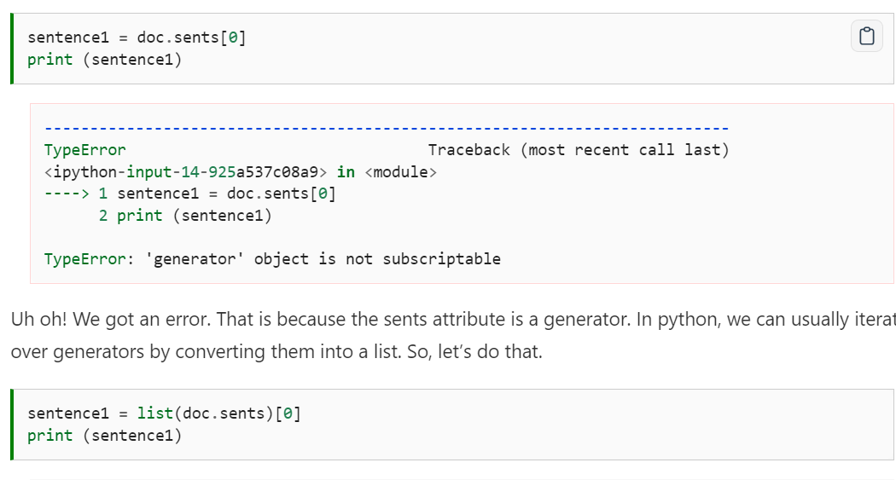

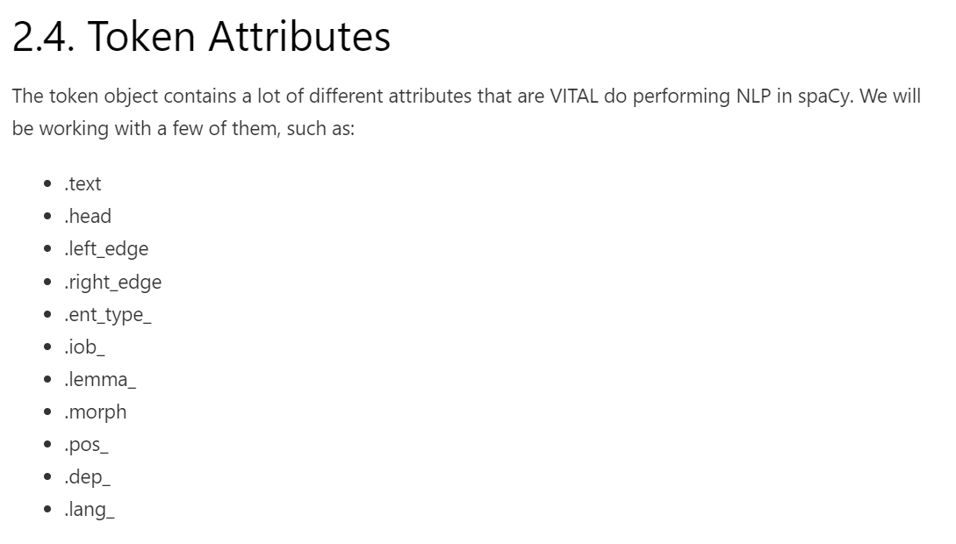

Sentense1



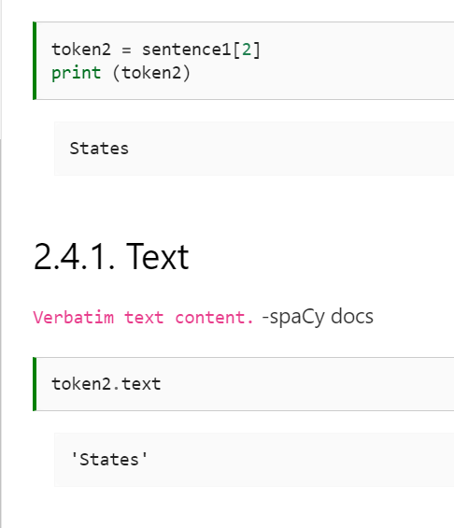

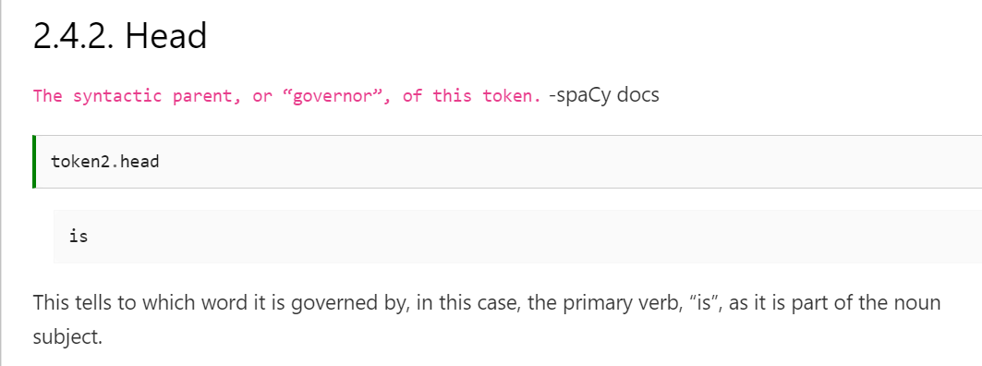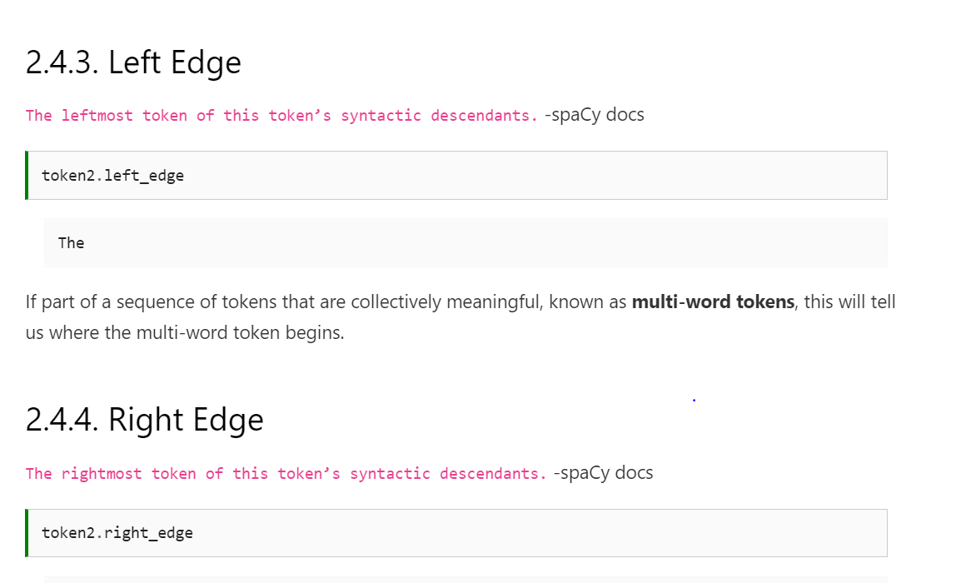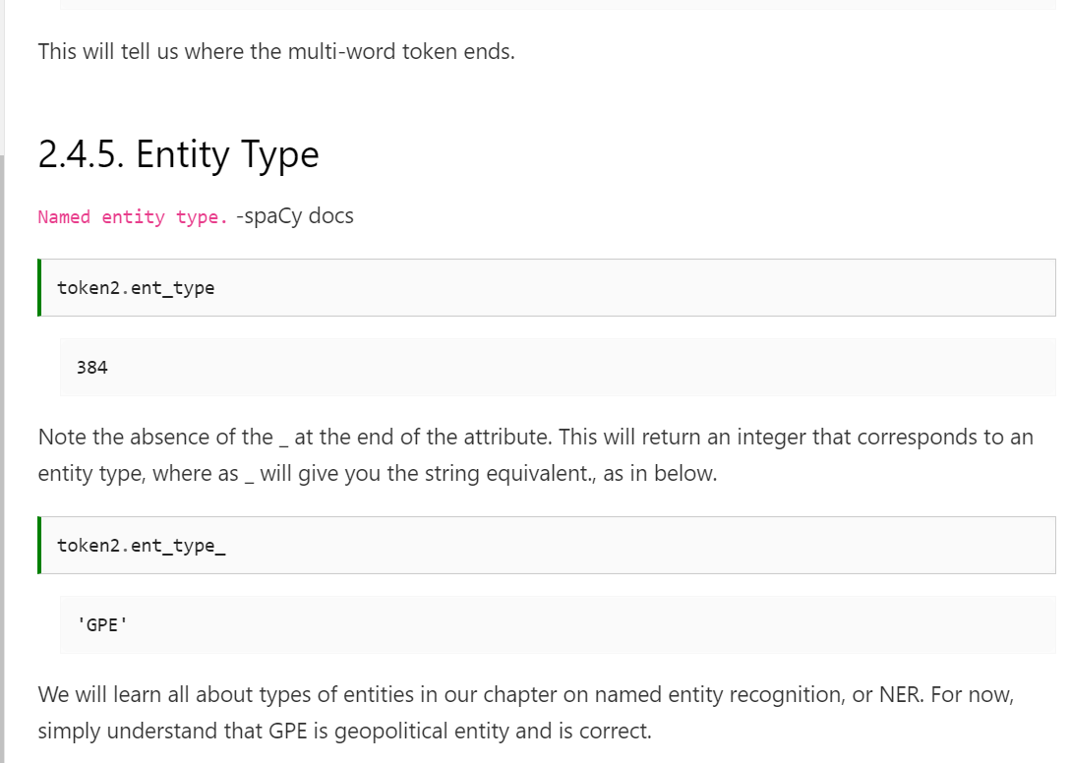

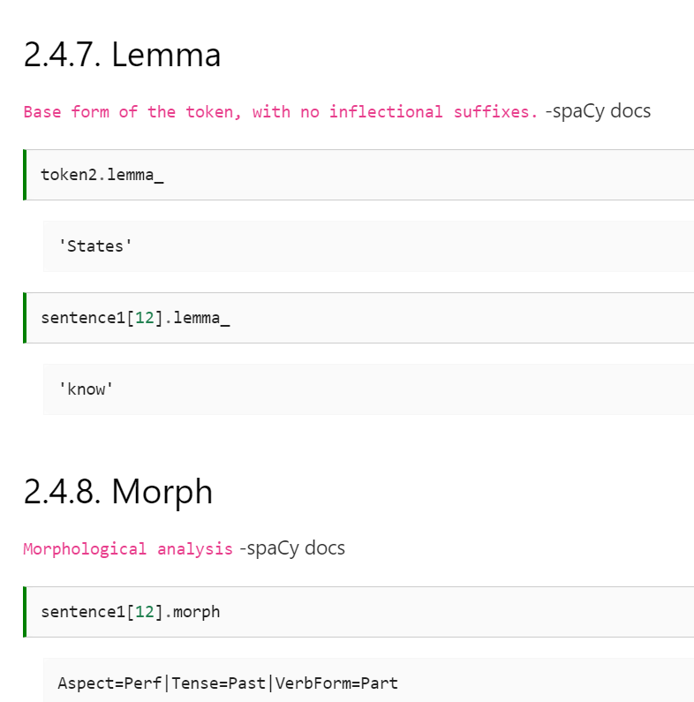

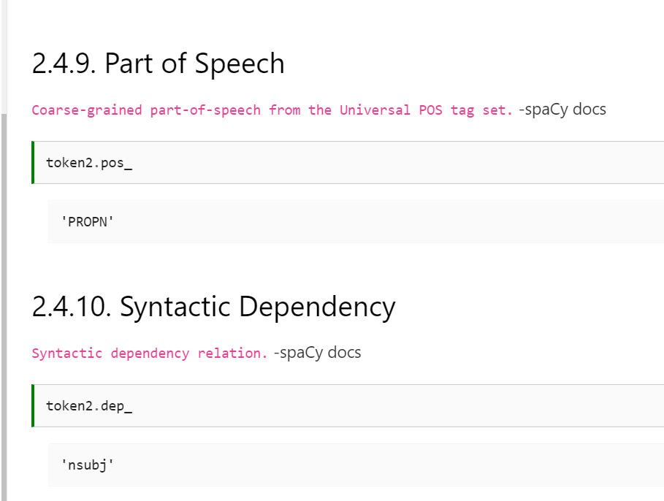

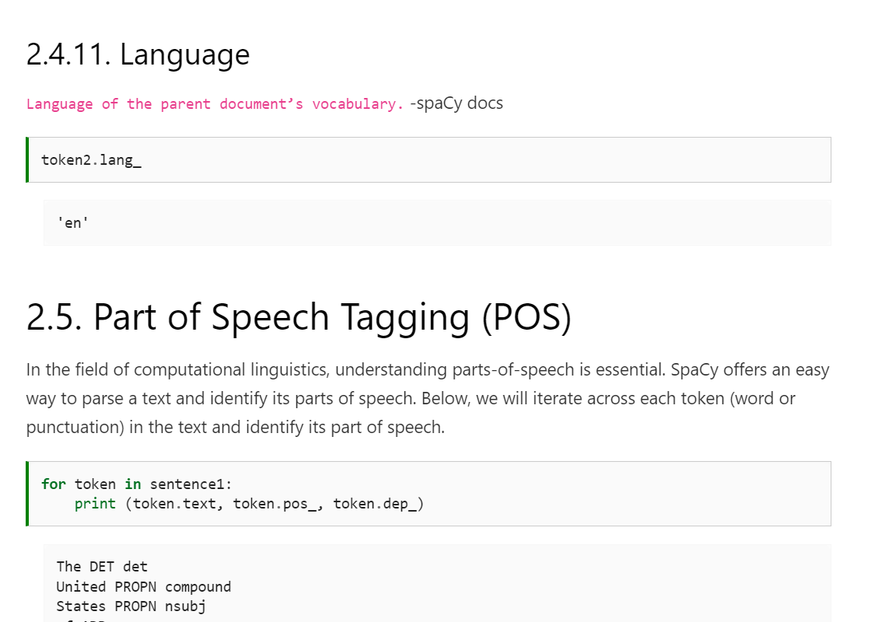

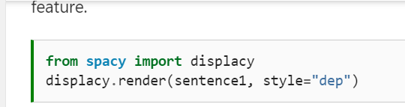

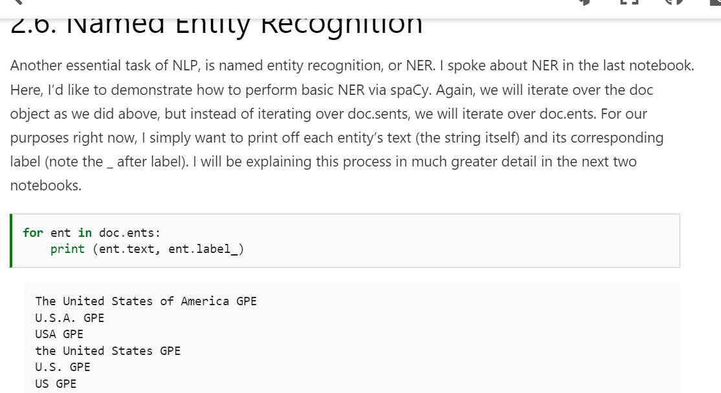

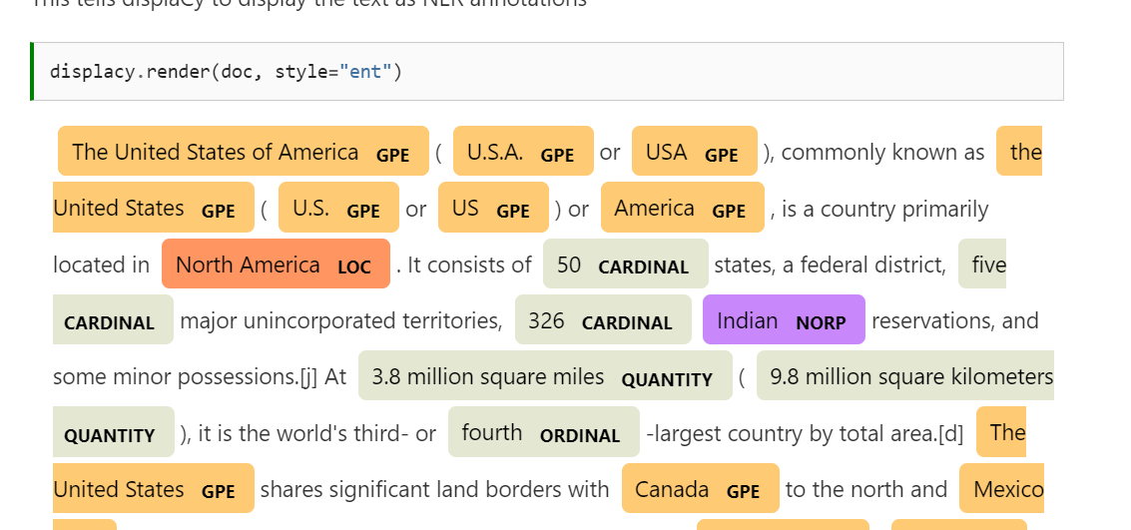

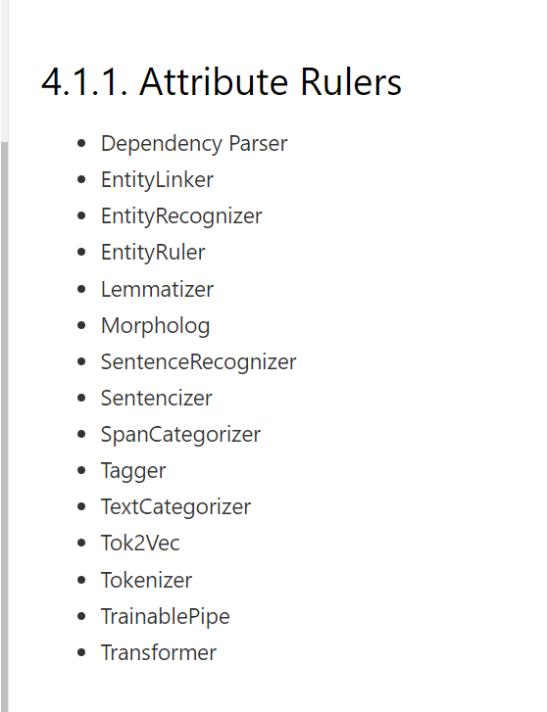

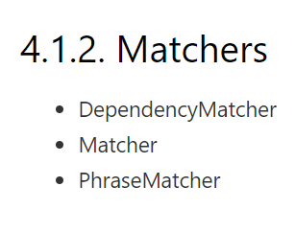

## 4.2. How to Add Pipes[¶](http://spacy.pythonhumanities.com/01_04_pipelines.html#how-to-add-pipes)

In most cases, you will use an off-the-shelf spaCy model. In some cases, however, an off-the-shelf model will not fill your needs or will perform a specific task very slowly.

A good example of this is sentence tokenization.

Imagine if you had a document that was around 1 million sentences long. Even if you used the small English model, your model would take a long time to process those 1 million sentences and separate them

. In this instance, you would want to make a **blank English** model and **simply add the Sentencizer to it.** The reason is because each pipe in a pipeline will be activated (unless specified) and that means that each pipe from Dependency Parser to named entity recognition will be performed on your data. This is a serious waste of computational resources and time. The small model may take hours to achieve this task. By creating a blank model and simply adding a Sentencizer to it, you can reduce this time to merely minutes.

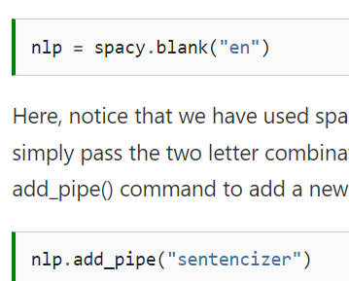

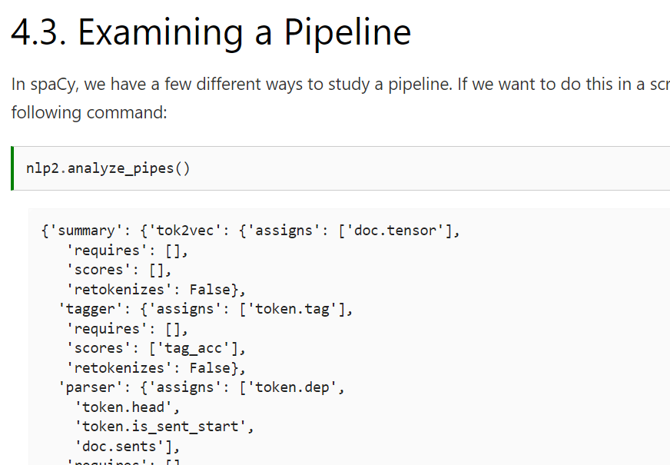

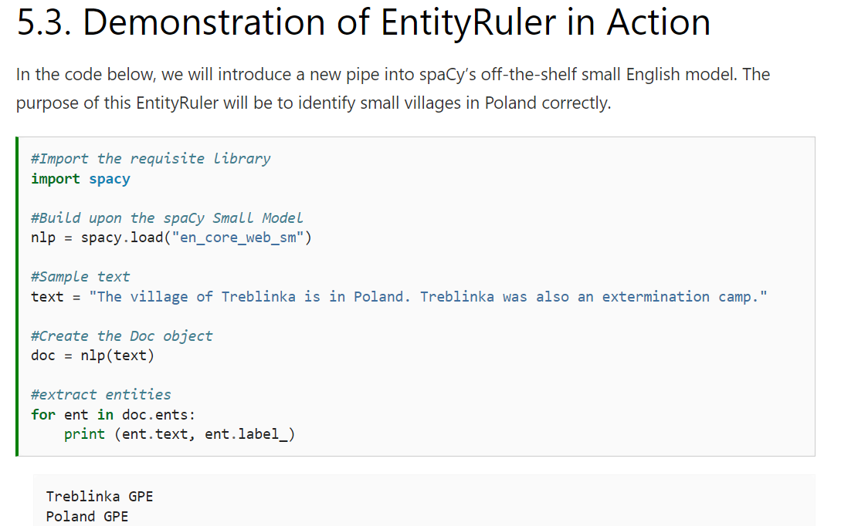

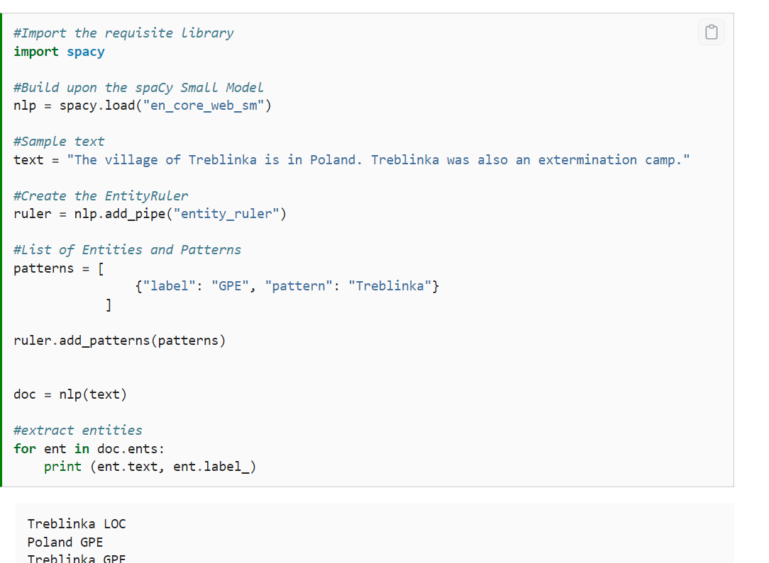

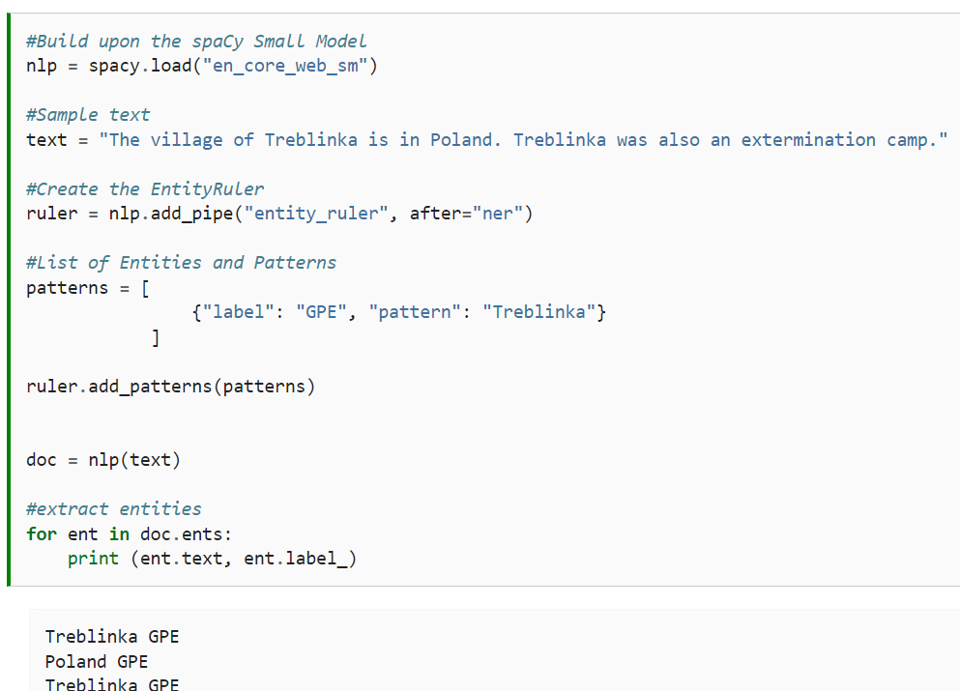

## Introducing Complex Rules and Variance to the EntityRuler (Advanced)[¶](http://spacy.pythonhumanities.com/02_01_entityruler.html#introducing-complex-rules-and-variance-to-the-entityruler-advanced)

In some instances, labels may have a set type of **variance** that follow a **distinct pattern** or sets of patterns. One such example (included in the spaCy documentation) is phone numbers. In the United States, phone numbers have a few forms.

The standard formal method is (xxx)-xxx-xxxx, but it is not uncommon to see xxx-xxx-xxxx or xxxxxxxxxx. If the owner of the phone number is giving that same number to someone outside the US, then +1(xxx)-xxx-xxxx.

If you are working within a United States domain, you can pass RegEx formulas to the pattern matcher to grab all of these instances.

The spaCy EntityRuler also allows the user to introduce a variety of complex rules and variances (via, among other things, RegEx) by passing the rules to the pattern. There are many arguments that one can pass to the patterns. For a complete list, see: https://spacy.io/usage/rule-based-matching . To expiremnet with how these work, I recommend using the spaCy Matcher demo: https://explosion.ai/demos/matcher .

In the example below we work with one example from the spaCy documentation in which we extract a phone number from a text. This same task can be done via RegEx as well.

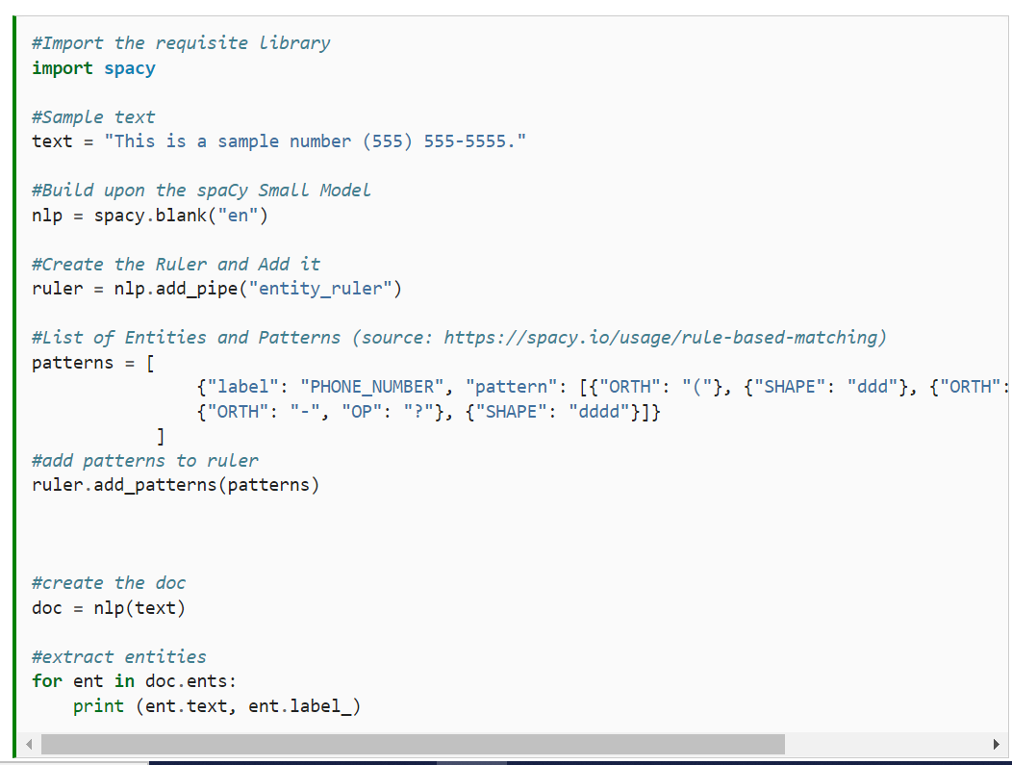

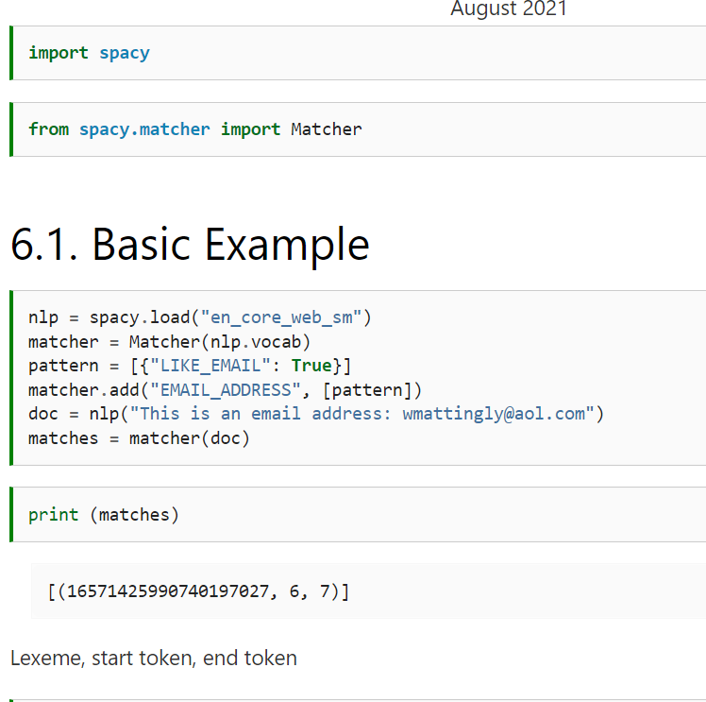

## Attributes Taken by Matcher[¶](http://spacy.pythonhumanities.com/02_02_matcher.html#attributes-taken-by-matcher)

* ORTH - The exact verbatim of a token (str)
* TEXT - The exact verbatim of a token (str)
* LOWER - The lowercase form of the token text (str)
* LENGTH - The length of the token text (int)
* IS_ALPHA
* IS_ASCII
* IS_DIGIT
* IS_LOWER
* IS_UPPER
* IS_TITLE
* IS_PUNCT
* IS_SPACE
* IS_STOP
* IS_SENT_START
* LIKE_NUM
* LIKE_URL
* LIKE_EMAIL
* SPACY
* POS
* TAG
* MORPH
* DEP
* LEMMA
* SHAPE
* ENT_TYPE
* _ - Custom extension attributes (Dict[str, Any])
* OP

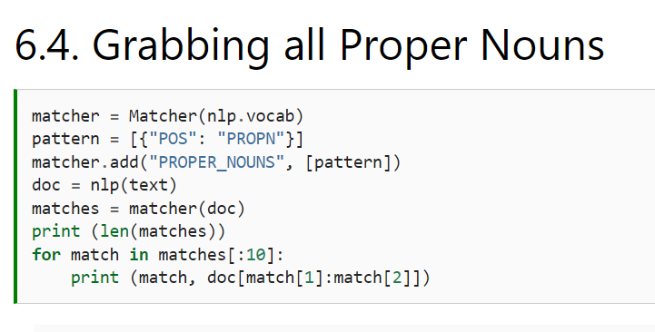

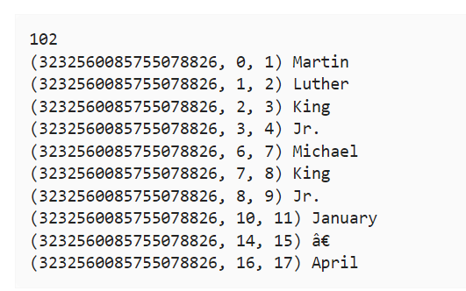

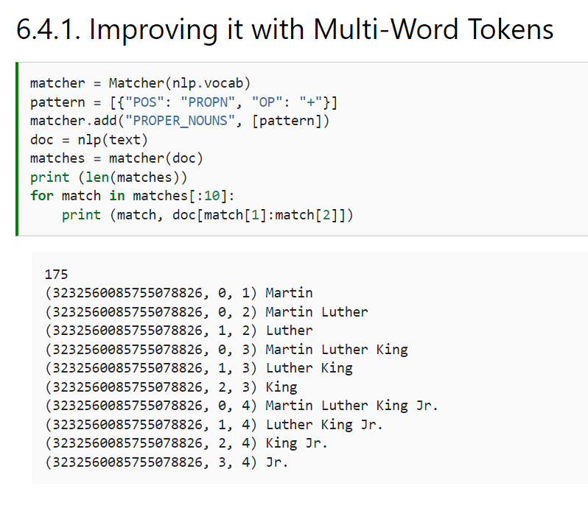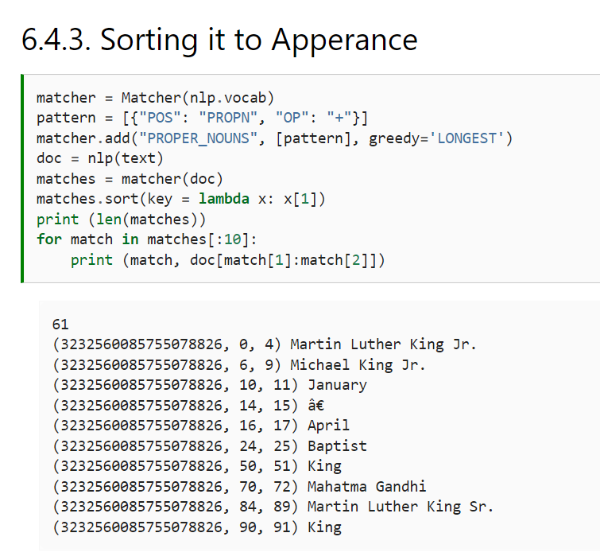

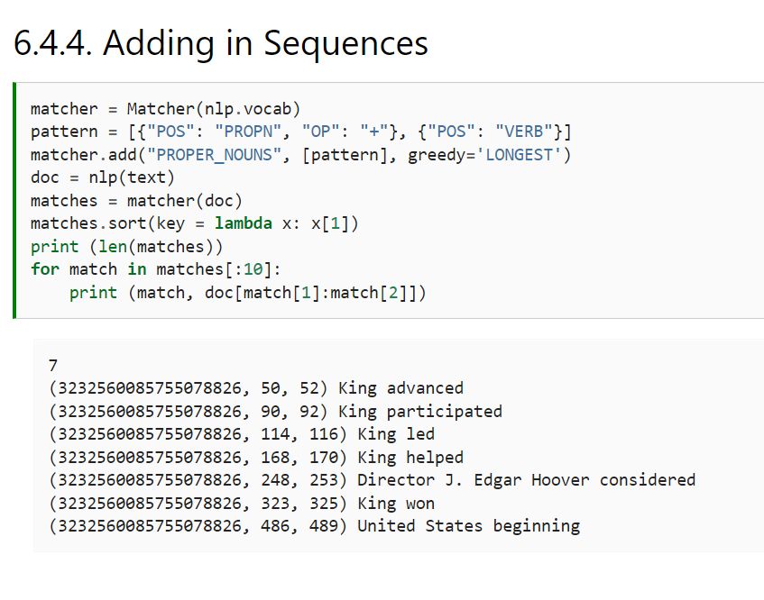

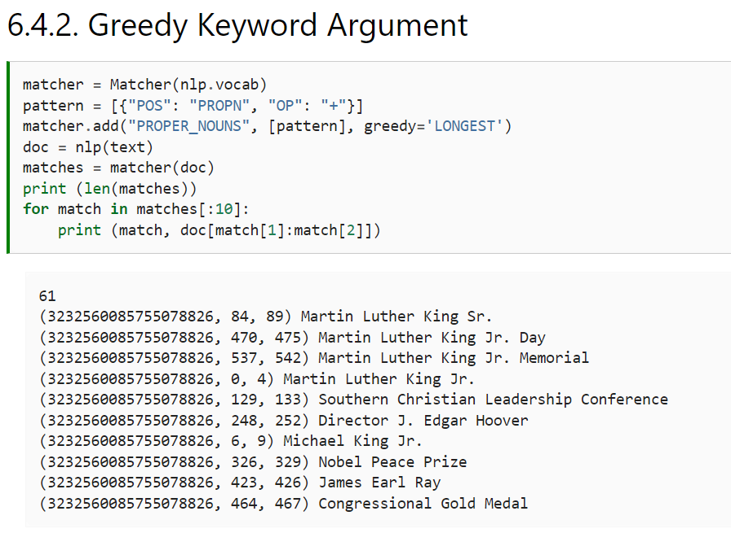

Creating an extension in spacy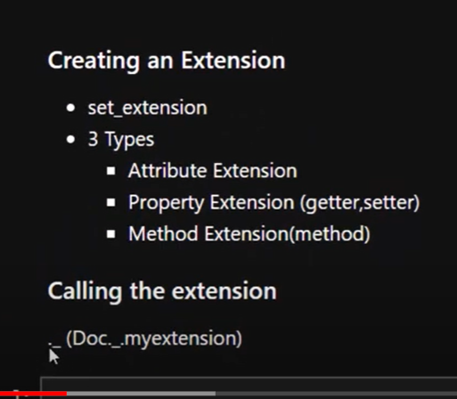

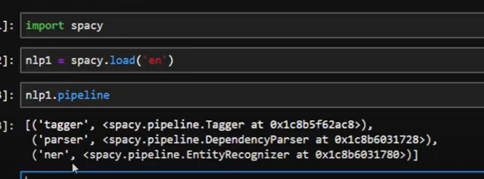

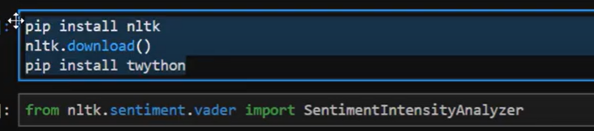

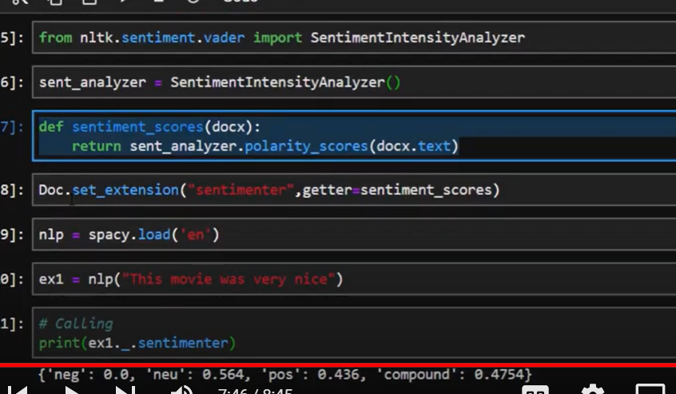

Text Summerization using spacy

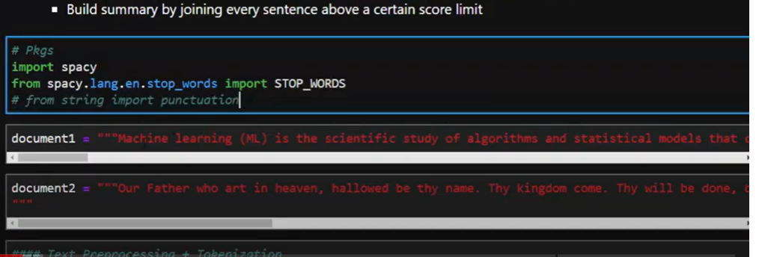

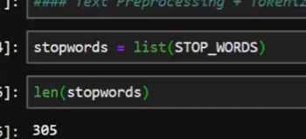

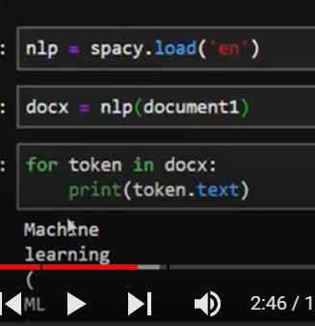

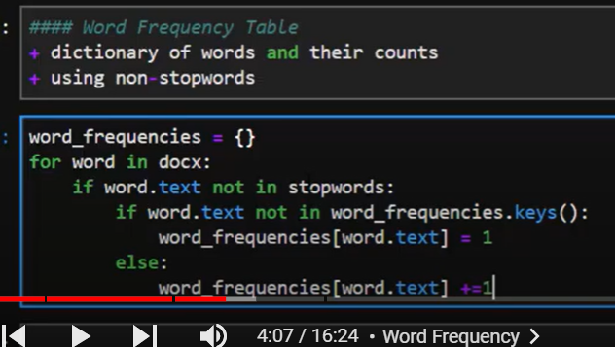

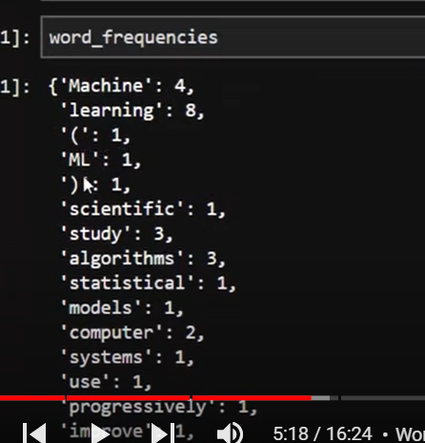

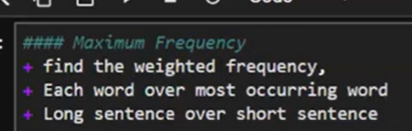

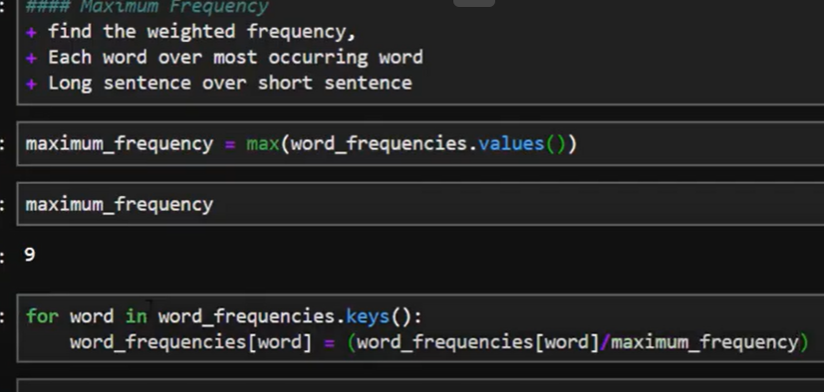

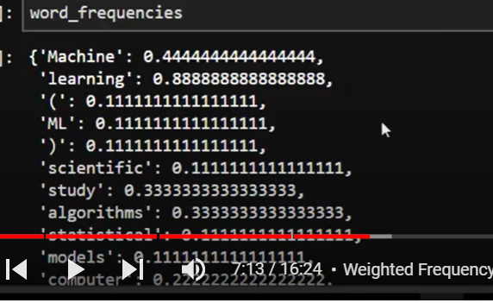

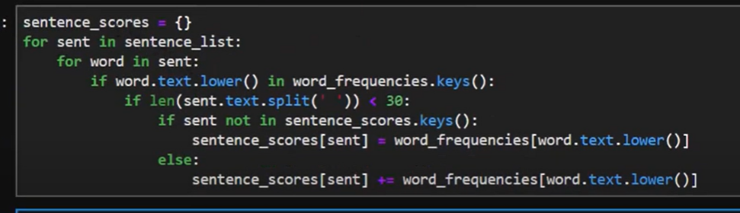

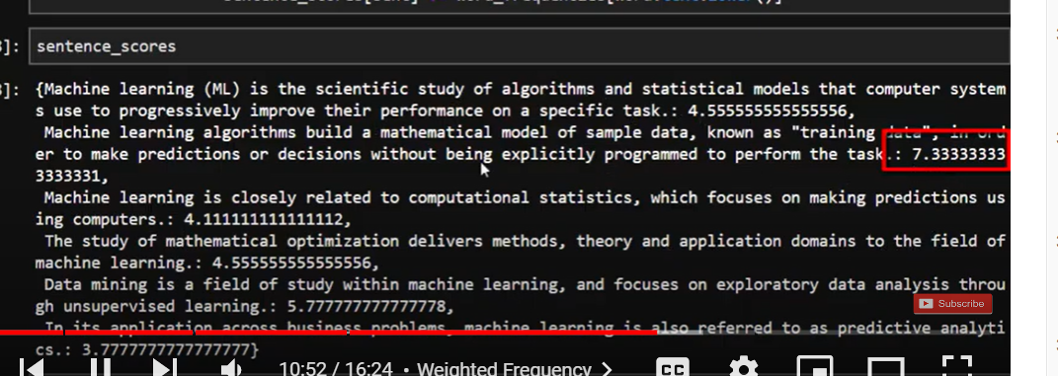

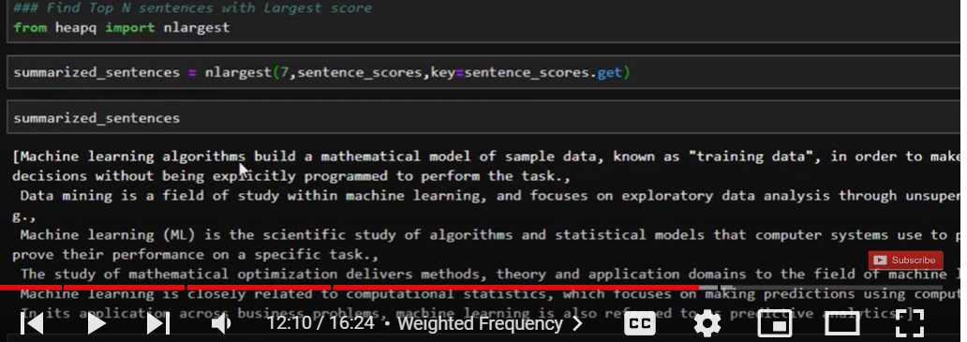

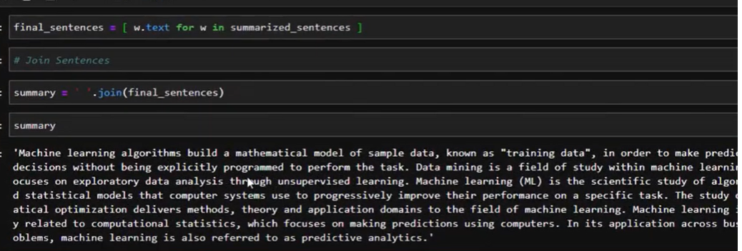

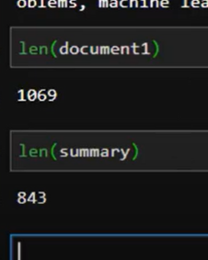

Text summarization with spacy

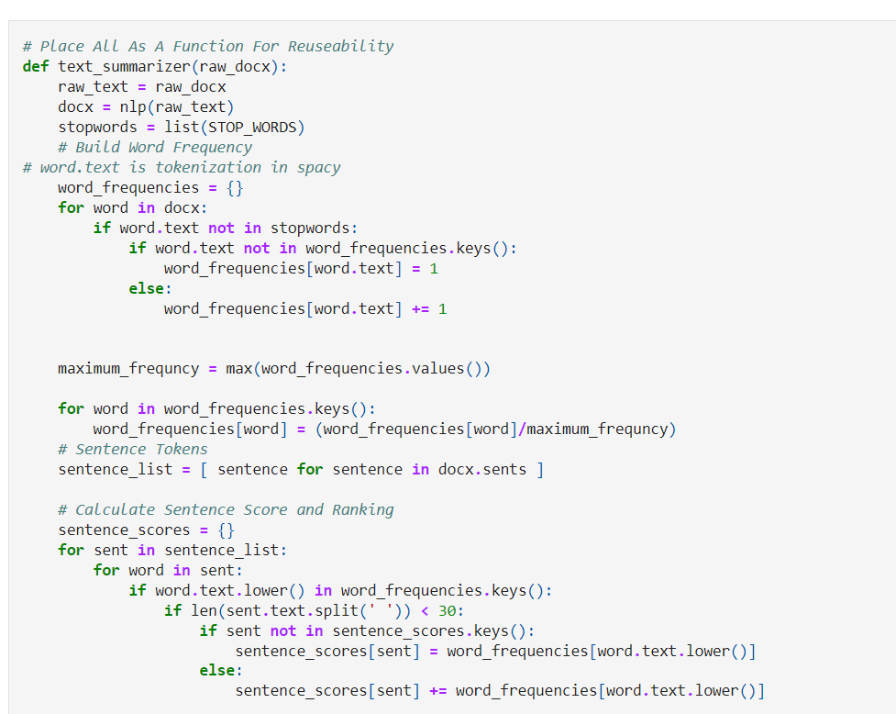

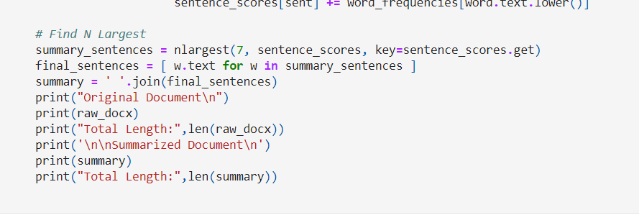

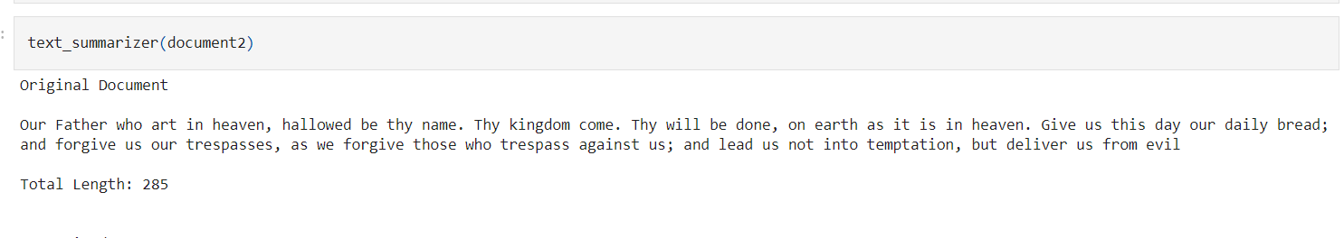

Text summarization using spacy

[Natural-Language-Processing-Tutorials/Text Summarization In SpaCy.ipynb at master · Jcharis/Natural-Language-Processing-Tutorials (github.com)](https://github.com/Jcharis/Natural-Language-Processing-Tutorials/blob/master/NLP_with_SpaCy/Text%20Summarization%20In%20SpaCy.ipynb)

# Spacy Python Tutorial - Document Sanitization(Redaction) with Named Entity Recognition

No personal information is identifiable

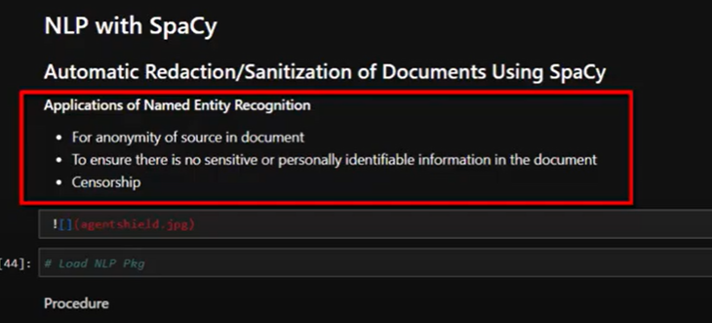

Identify named entities and replace with our word

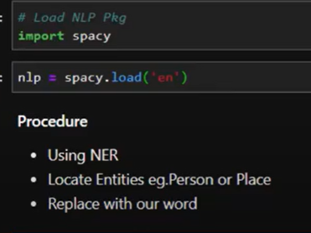

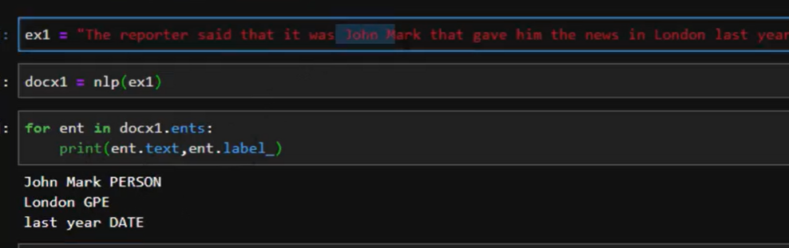

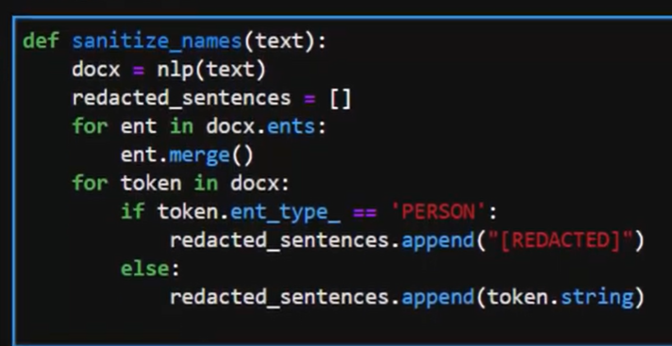

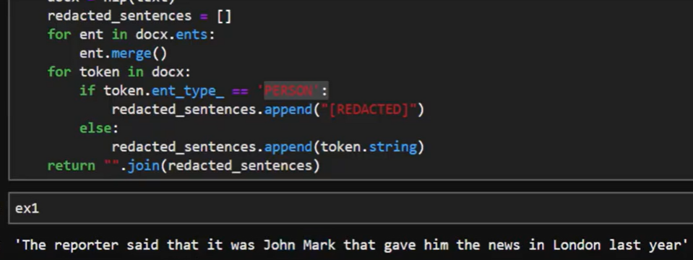

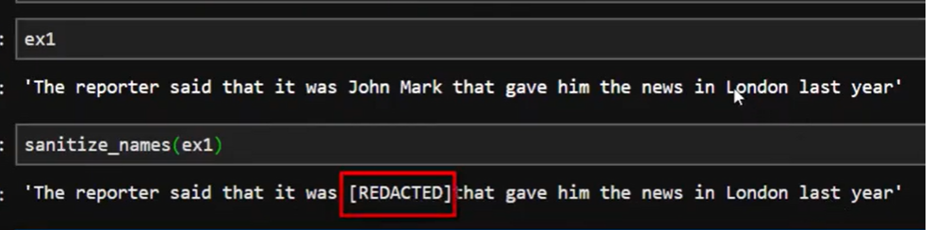

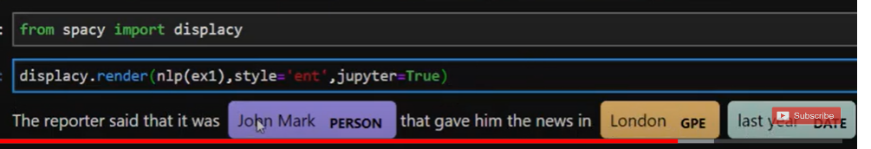

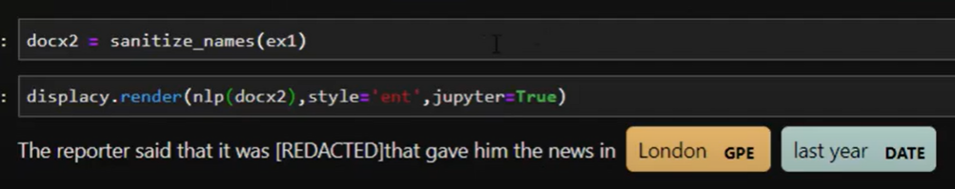

# Training Spacy's Named Entity Recognition to Recognize Drugs - NLP in Python

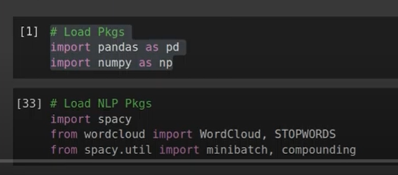

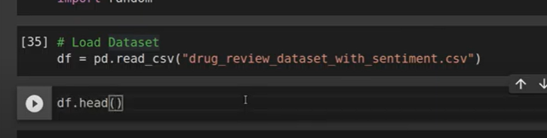

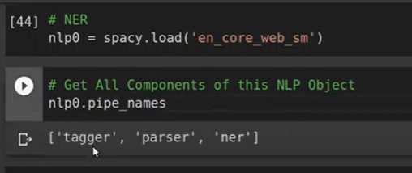

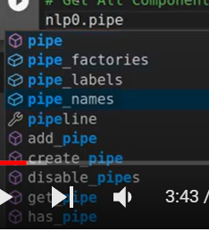

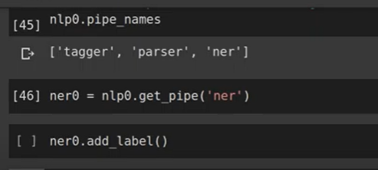

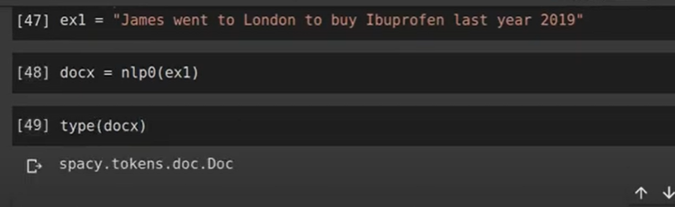

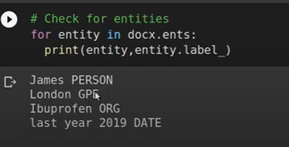

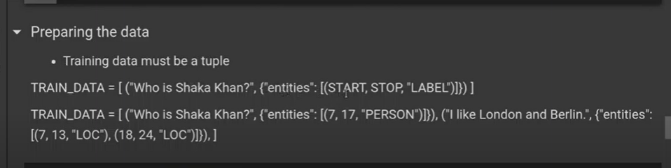

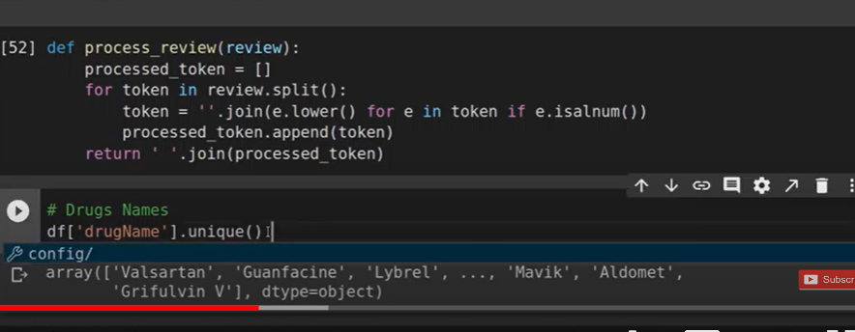

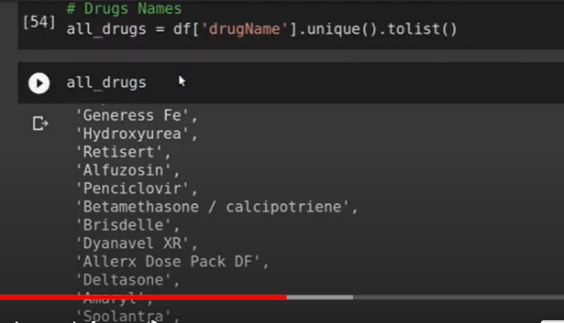

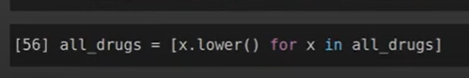

We need to identify all drugs in a review

And get their position and location

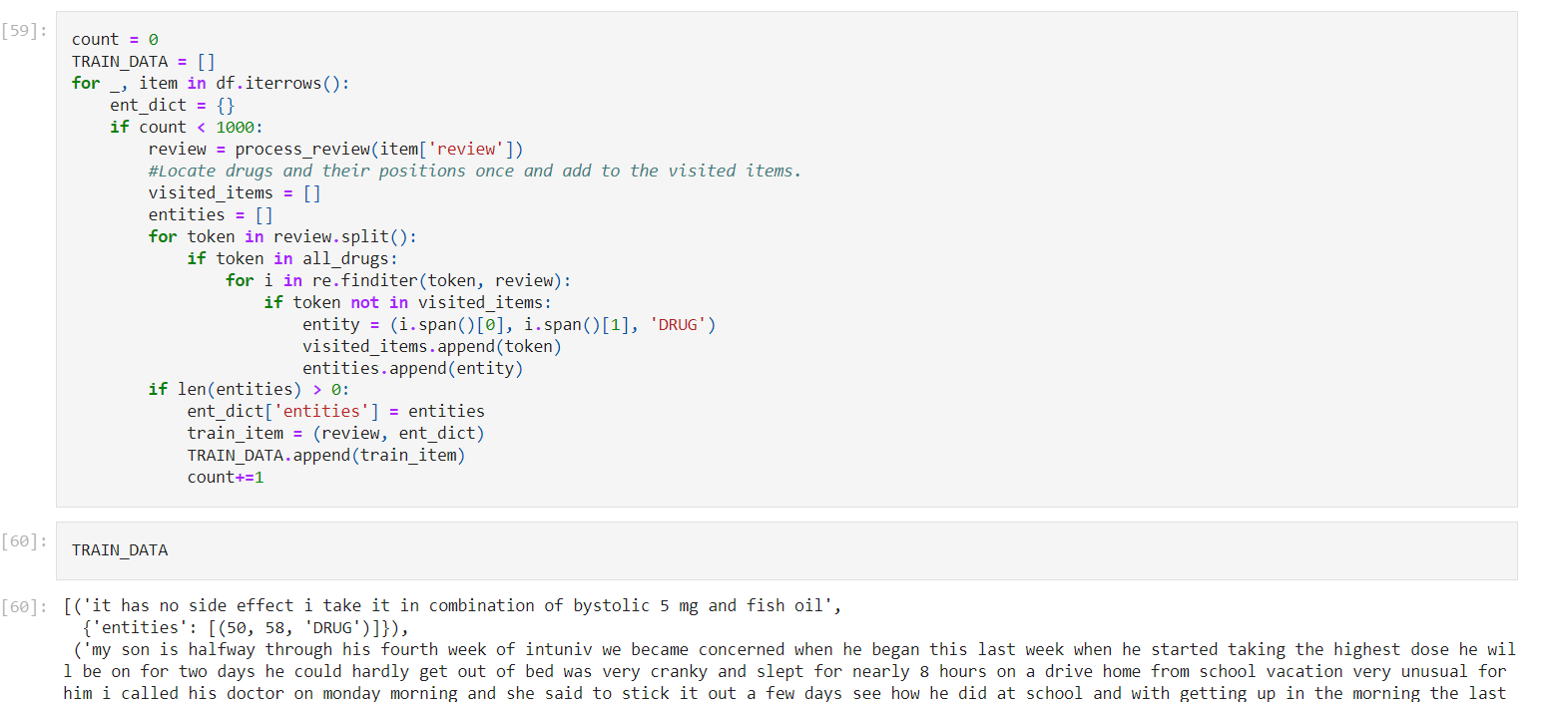

# Clinical Named Entity Recognition in Python with Spacy

[Clinical Named Entity Recognition in Python with Spacy - YouTube](https://www.youtube.com/watch?v=ZnSebx45SLk&list=PLJ39kWiJXSiz1LK8d_fyxb7FTn4mBYOsD&index=33)

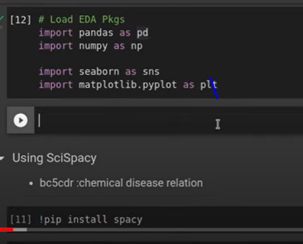

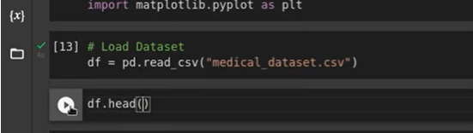

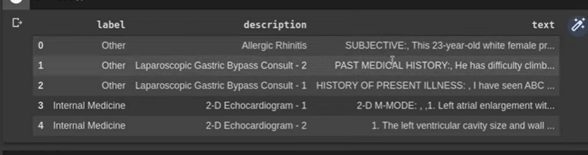

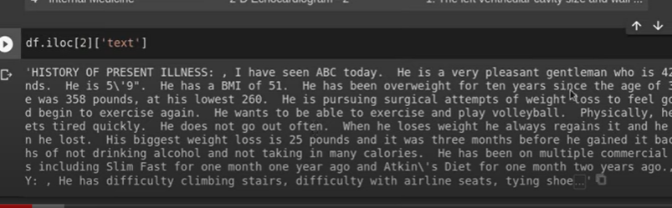

Scipy and model url

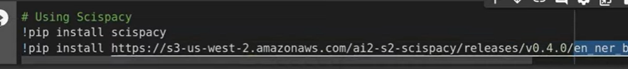

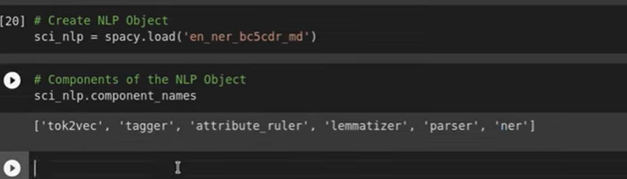

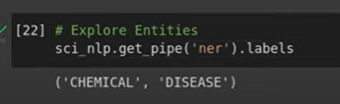

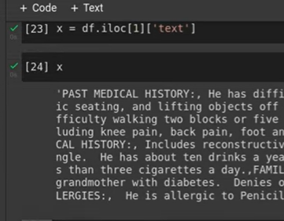

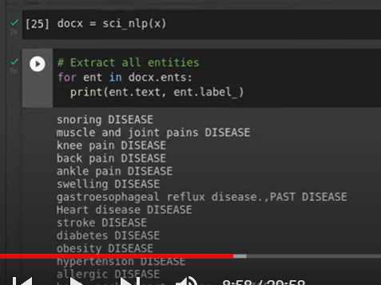

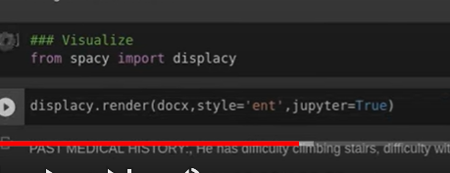

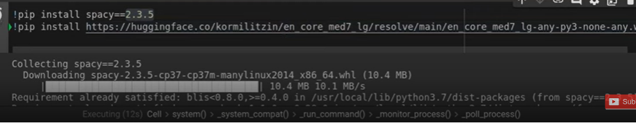

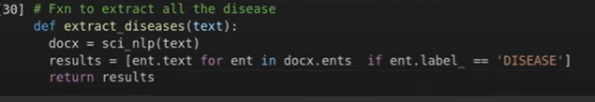



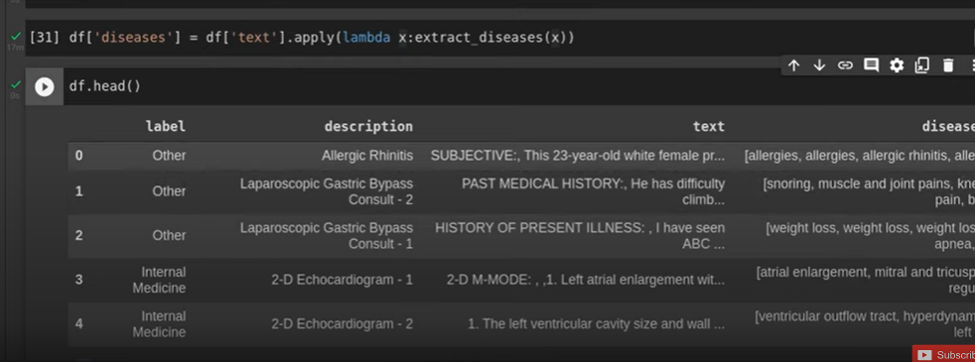

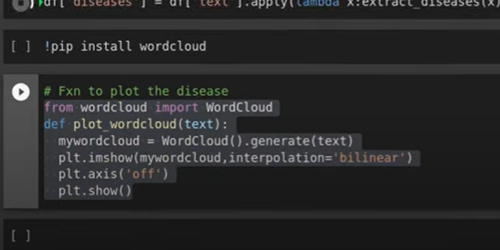

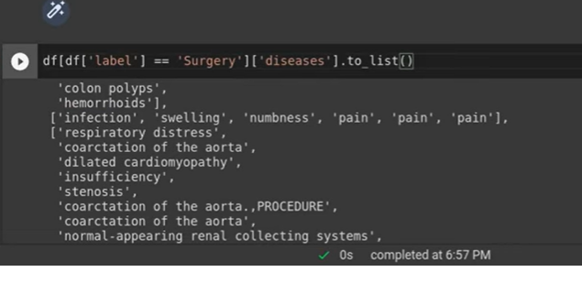

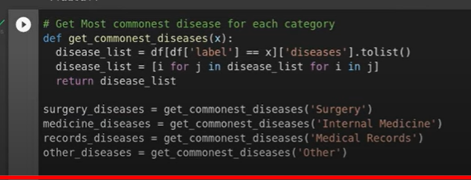

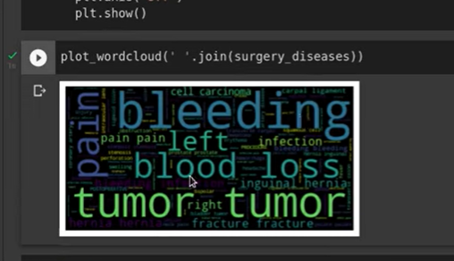

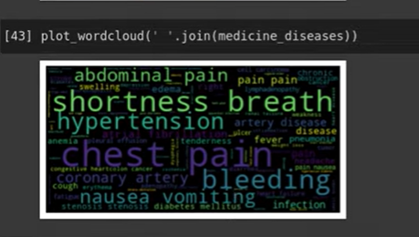

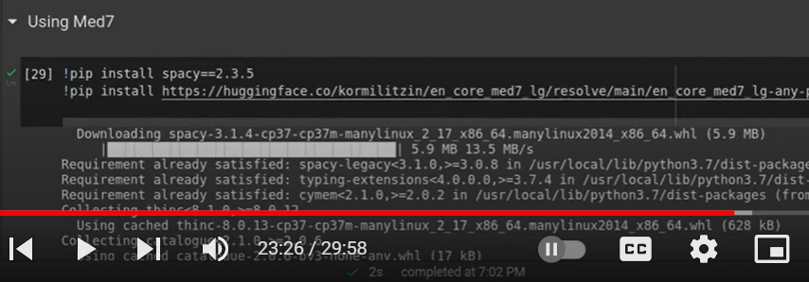

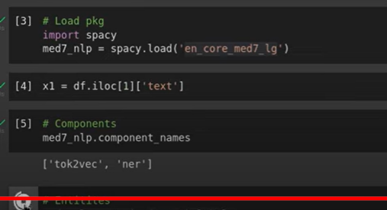

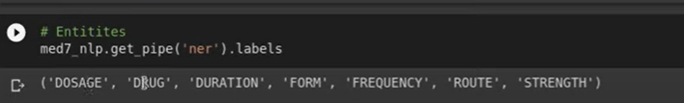

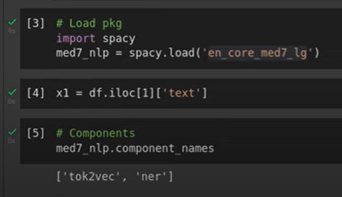

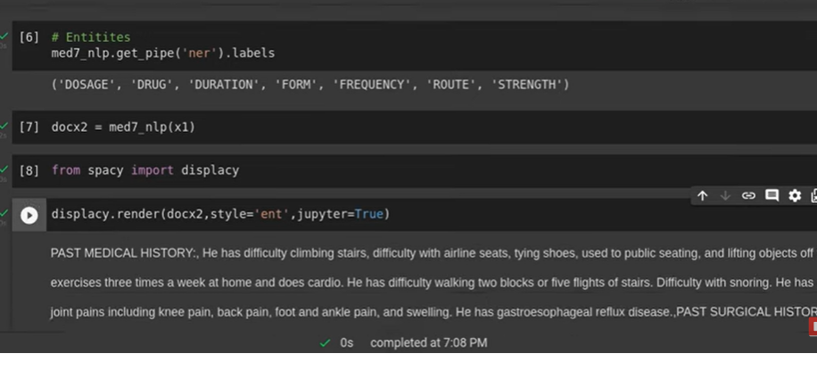

<https://www.youtube.com/playlist?list=PLc2rvfiptPSQgsORc7iuv7UxhbRJox-pW>

[Phone Number, Email, Emoji Extraction in SpaCy for NLP – KGP Talkie](https://kgptalkie.com/phone-number-email-emoji-extraction-in-spacy-for-nlp/)

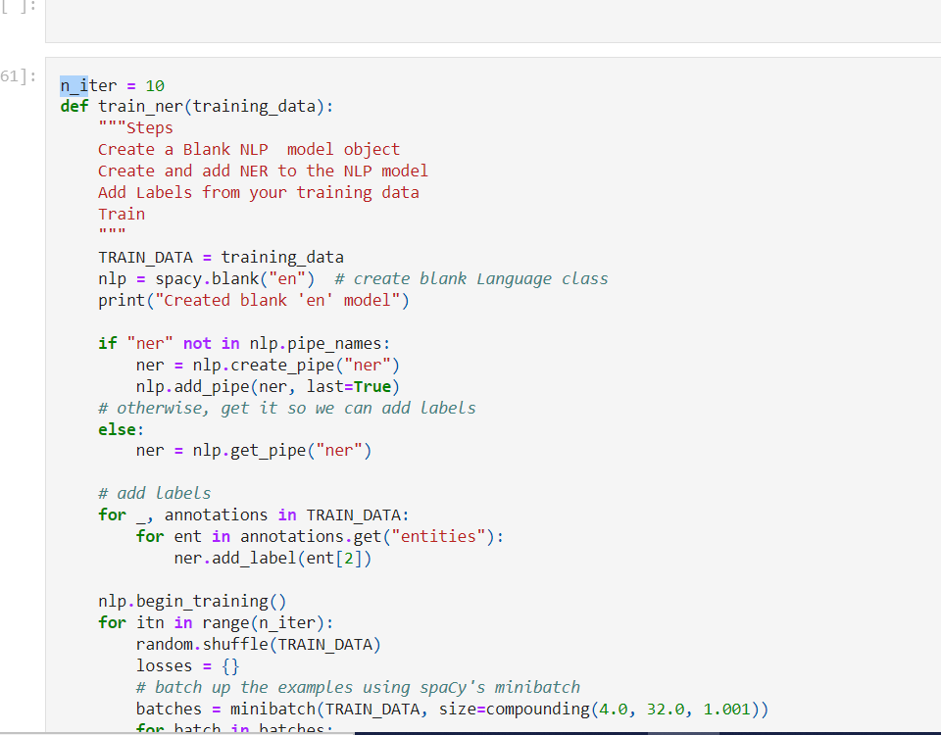

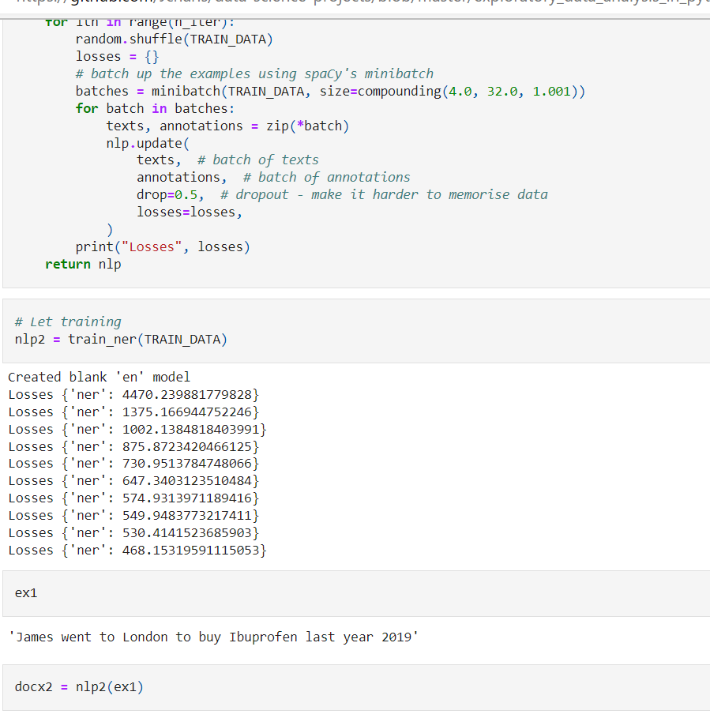

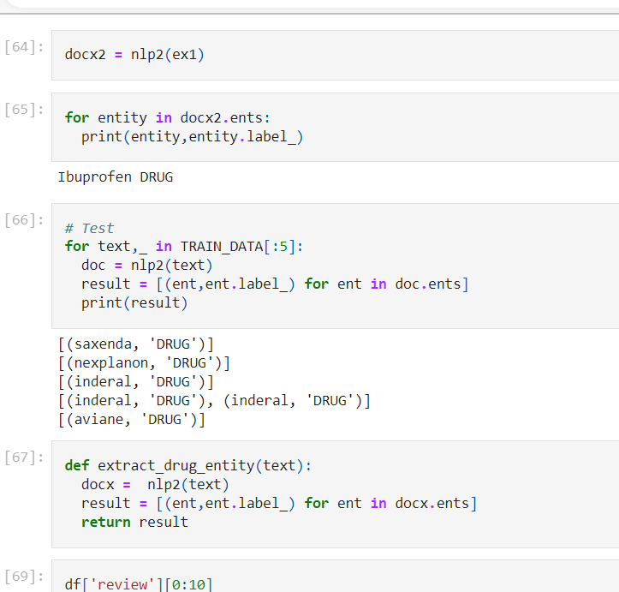

[spaCy NER Model to Identify Scientific Datasets — Coleridge Initiative | by Bao Tram Duong | Geek Culture | Medium](https://medium.com/geekculture/spacys-ner-model-to-identify-scientific-datasets-a336bec6190a)

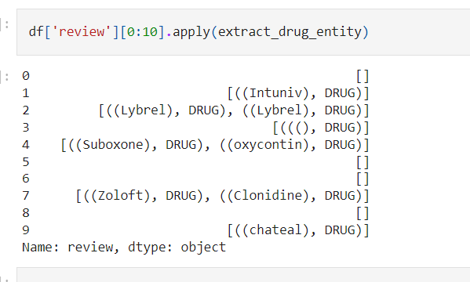

[data-science-projects/NLP on Drug Reviews Dataset.ipynb at master · Jcharis/data-science-projects (github.com)](https://github.com/Jcharis/data-science-projects/blob/master/exploratory_data_analysis_in_python_drug_reviews_dataset/Training%20Spacy's%20Named%20Entity%20Recognition%20to%20Recognize%20Drugs/NLP%20on%20Drug%20Reviews%20Dataset.ipynb)